TTWRDC(G) KHAMMAM

DEPARTMENT OF PHYSICS

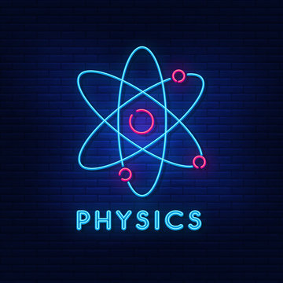

INDEX

S.NO | TOPICNAME | PAGE  NUMBERS
S.NO | TOPICNAME | FROM | TO
1 | HISTORY OF THE DEPARTMENT | 1 | 3
2 | AIMS AND OBJECTIVES | 4 | 5
3 | VISION AND MISSION | 5 | 6
4 | SWOC ANALYSIS | 6 | 7
5 | TEACHING FACULTYAND THEIR PROFILES | 8 | 10
6 | CURRICULAR ASPECTS (CRITERIA –I) | 11 | 18
7 | TEACHING LEARNING AND EVALUATION(CRITERIA-II) | 19 | 46
8 | RESEARCH,CONSULTANCY AND TEACHING(CRITERIA-III) | 47 | 50
9 | INFRASTRUCTURE AND LEARNING RESOURCES(CRITERIA-IV) | 51 | 60
10 | STUDENTS SUPPORT AND PROGRESSION(CRITERIA-V) | 61 | 62
11 | GOVERNANCE,LEADERSHIP AND MANAGEMENT(CRITERIA-VI) | 63 | 66
12 | INSTITUTIONAL VALUES AND BEST PRACTICES(CRITERIA-VII) | 67 | 68
13 | SIGNIFICANT ACHIEVEMENTS | 75 | 92
14 | FUTURE PLAN | 93 | 94

INTRODUCTION

- The Department of Physics was started in the year 2018 and mainly concentrates on introducing scientific methodology to rural students.
- This is systematically done by concept oriented learning with supporting experimental proofs.
- The department gives knowledge in Physics for undergraduate students as per Kakatiya University curriculum.
- The Department deals mostly with rural students the faculty works hard to Improve positive attitude and Scientific Temper among students
- Motivate students to go for higher studies in Physics.
- The department has a spacious Laboratory cum dark room. The department is having all the requirements to train the students both in theory and practicals
- The department has well trained and dedicated faculty.

AIMS AND OBJECTIVES

- The Department deals mostly with rural students the faculty works hard to Improve positive attitude and Scientific Temper among students
- Motivate students to go for higher studies in Physics.
- The department has a spacious Laboratory cum dark room. The department is having all the requirements to train the students both in theory and practicals
- The department has well trained and dedicated faculty.

VISION AND MISSION

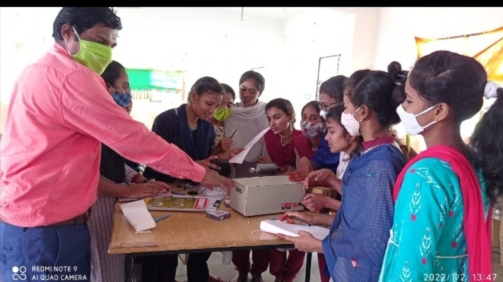

Vision:
- To awaken the young minds and discover their talents both in theory and in practical Physics through dedication to Teaching.
- To support the progression of students and igniting their minds to set their goal in a premier and prestigious institution.
Mission:
- To support the development activities of the college and make the department vibrant.
- To groom our students to become professionally and morally rich in Scientific Knowledge.
- To bring quality Education for effective Learning of the students.

STRENGTH,WEAKNESS,OPPORTUNITIES&CONSTRAINTS
STRENGTHS
- Qualified & Experienced Faculty
- Rich knowledge of Digital tools
- Well equipped laboratories
- Well ventilated lecture halls and
ambient college atmosphere
WEAKNESSES
- Less faculty in the department.
- Limited funding.
- Lack of classrooms and laboratories.
- Students are economically and socially poor.

OPPORTUNITIES

- Research orientation
- Exchange of knowledge through
- Guest lectures and MoUs.
- Choice Based Credit System (CBCS) enables students to learn subjects as per their choice.

CHALLENGES
1.Student’s transportation promoting to higher education due to
early age marriages
2. Collaboration with reputed organisations

BIO-DATA OF THE STAFF
YEAR | NAME | DESIGNATION | PHOTO
2018-20 | M.NAGASRI | M.Sc., | 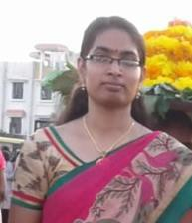
2019-2024 | K.MANASA | M.Sc.,B.Ed,SET | 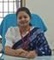

8

 | 2020-24 | B.HAREESH | M.Sc.,PGDIT,SET | 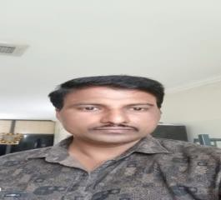
 | 2022-23 | T.BHAVANI | M.Sc.,NET | 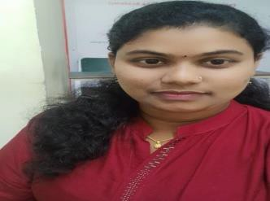
 | 2023-24 | PRAVALIKA | M.Sc.,B.Ed | 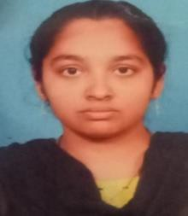
 | 2023-24 | N.MOUNIKA | M.Sc.,B.Ed | 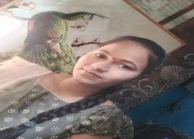

9

PRESENT WORKING STAFF

NAME | QUALIFICATION | PHOTO
A.SWARNAKUMARI | M.Sc, B.ed, NET, | 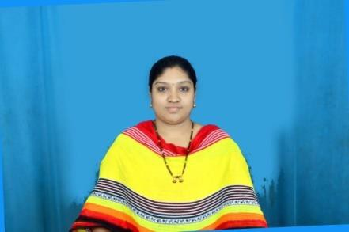
M.MANGAVENI | M.Sc., | 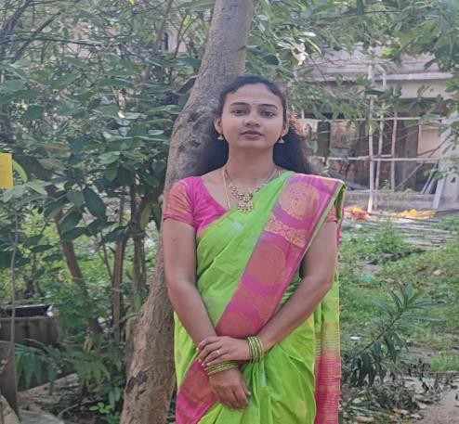

CRITERIA-I CURRICULAR ASPECTS

COURSESOFFERED
- At the inception of the college both MPC AND MPCS were introduced in English medium.
Syllabus2016-2019Semesterwise

KAKATIYAUNIVERSITY,WARANGAL

SCHEME FOR CHOICE BASED CREDITSYSTEM B.Sc. (PHYSICS)
SEMESTERPATTERN

YEAR | SEM | COURSE(PAPER)TITLEWITHCODE | COURSE TYPE* | HRS/ WEEK | CREDITS | MARKS
 |  |  |  |  |  | Internal Assessment | SEM End Exam
FIR  ST | I | 101: Mechanics | DSC-1 | 4 | 4 | 20 | 80
FIR  ST | I | 101(P):Mechanics Lab(Pr) | DSC-1(P) | 3 | 1 | - | 25
FIR  ST | II | 201:Wavesand Oscillations | DSC-2 | 4 | 4 | 20 | 80
FIR  ST | II | 201(P):Waves and Oscillations Lab (Pr) | DSC-2(P) | 3 | 1 | - | 25
SECO  ND | III | 301:ThermalPhysics | DSC-3 | 4 | 4 | 20 | 80
SECO  ND | III | 301(P): Thermal Physics Lab(Pr) | DSC-3(P) | 3 | 1 | - | 25
SECO  ND | IV | 401: Optics | DSC-4 | 4 | 4 | 20 | 80
SECO  ND | IV | 401(P):Optics Lab(Pr) | DSC-4(P) | 3 | 1 | - | 25
THIRD | V | 501:Electromagnetism | DSC-5 | 3 | 3 | 15 | 60
THIRD | V | 501(P):Electromagnetism Lab(Pr) | DSC-5(P) | 3 | 1 | - | 25
THIRD | V | 502:Elective(Theory)–1(A/B/C)  - Solid state physics  - Modern Optics | DSE-1 | 3 | 3 | 15 | 60
THIRD | V | 502(P):Elective(Practical)-1(A/B/C)  - Solid state physics Lab  - Modern Optics Lab | DSE-1(P) | 3 | 1 | - | 25
THIRD | VI | 601:ModernPhysics | DSC-6 | 3 | 3 | 15 | 60
THIRD | VI | 601(P):Modern PhysicsLab(Pr) | DSC-6(P) | 3 | 1 | - | 25
THIRD | VI | 602:Elective(Theory)–2(A/B/C)  - Basic Electronics  - Physics of Semiconductor devices | DSE-2 | 3 | 3 | 15 | 60
THIRD | VI | 602(P):Elective(Practical)–2(A/B/C)  - Basic Electronics Lab  - Physics of Semiconductor devices Lab | DSE-2(P) | 3 | 1 | - | 25
 |  | Total |  |  | 36 | 140 | 760
 |  |  |  |  |  | GrandTotal:900
*DSC: Discipline Specific Course (Core) DSE: Discipline Specific Elective(Elective)

PAPERS AND CREDITS

B.Sc.(PHYSICS)

KAKATIYAUNIVERSITY,WARANGAL

SUMMARY OF CREDITS

SEM | CourseType* | Credits/M arks (Theory) (Internal  +Sem End Exam) | HPW  (Theory) | Credits/ Marks (Practical) | HPW  (Practical) | Deptworkload per week per section
I | DSC- Core | 4 /(20+80) | 4 | 1/25 | 3 | 6
II | DSC- Core | 4 /(20+80) | 4 | 1/25 | 3 | 6
III | DSC- Core | 4 /(20+80) | 4 | 1/25 | 3 | 6
IV | DSC- Core | 4 /(20+80) | 4 | 1/25 | 3 | 6
V | DSC- Core | 3 /(15+60) | 3 | 1/25 | 3 | 5
V | DSE-Elective(A/B) | 3 /(15+60) | 3 | 1/25 | 3 | 5
VI | DSC- Core | 3 /(15+60) | 3 | 1/25 | 3 | 5
VI | DSE-Elective(A/B) | 3 /(15+60) | 3 | 1/25 | 3 | 5
 | Total | 28 /700 | 28 | 8 /200 | 24 | 52
*DSC: Discipline Specific Course, DSE: Discipline Specific Elective

COURSEOUTCOMES
The Outcomes of UG Course, B.Sc. in Physics
After completion of B. Sc. in Physics students are able to:
Demonstrate a rigorous understanding of the core theories & principles of physics, which includes mechanics, electromagnetism, thermodynamics, & quantum mechanics.
- Learn the Concepts as Quantum Mechanics, Relativity, introduced at degree level in order to understand nature at atomic levels.
- Provide knowledge about material properties and its application for developing technology to ease the problems related to the society.
- Understand the set of physical laws, describing the motion of bodies, under the influence of system of forces.
- Understand the relationship between particles & atom, as well as their creation & decay.
- Relate the structure of atoms & subatomic particles
- Understand physical properties of molecule the chemical bonds between atom as well as molecular dynamics.
- Analyze the applications of mathematics to the problems in physics & develop suitable mathematical method for such application & for formulation of physical theories.
- Learn the structure of solid materials & their different physical properties along with metallurgy, cryogenics, electronics, & material science.
- Understand the fundamental theory of nature at small scale & levels of atom & sub-atomic particle.
P-III: ELECTRCITY AND MAGNETISM (Credits: 07, Theory-04, Practicals-03)
Course learning outcome: After going through the course, the student should be able to Demonstrate
- Gauss law, Coulomb’s law for the electric field, Demonstrate Gauss law, Coulomb’s law for the electric field, and apply it to systems of point charges as well as line, surface, and volume distributions of charges.
- Explain and differentiate the vector (electric fields, Coulomb’s law) and scalar (electric potential, electric potential energy) formalisms of electrostatics. Apply Gauss’s law of electrostatics to solve a variety of problems.
- Articulate knowledge of electric current, resistance and capacitance in terms of electric field and electric potential. Demonstrate a working understanding of capacitors.
- Describe the magnetic field produced by magnetic dipoles and electric currents.
- Explain Faraday-Lenz and Maxwell laws to articulate the relationship between electric and magnetic fields. Understand the dielectric properties, magnetic properties of materials and the phenomena of electromagnetic induction. Describe how magnetism is produced and list examples where its effects are observed.
- Apply Kirchhoff’s rules to analyze AC circuits consisting of parallel and/or series combinations of voltage sources and resistors and to describe the graphical relationship of resistance, capacitor and inductor.
- Apply various network theorems such as Superposition, Thevenin, Norton, Reciprocity, Maximum Power Transfer, etc. and their applications in electronics, electrical circuit analysis, and electrical machines.
- In the laboratory course the student will get an opportunity to verify various laws in electricity and magnetism such as Lenz’s law, Faraday’s law and learn about the construction, working of various measuring instruments.
- Should be able to verify of various circuit laws, network theorems elaborated above using simple electric circuits.
- (X) Skills to be learned: This course will help in understanding basic concepts of electricity and magnetism and their applications. Basic course in electrostatics will equips the student with required prerequisites to understand electrodynamics phenomena.

P-IV: WAVES AND OPTICS
(Credits: 07, Theory-04, Practicals-03)
Course learning outcome: This course will enable the student to
- Recognize and use a mathematical oscillator equation and wave equation, and derive these equations for certain systems.
- Apply basic knowledge of principles and theories about the behaviour of light and the physical environment to conduct experiments.
- Understand the principle of superposition of waves, so thus describe the formation of standing waves.
- Explain several phenomena we can observe in everyday life that can be explained as wave phenomena.
- Use the principles of wave motion and superposition to explain the Physics of polarisation, interference and diffraction. Understand the working of selected optical instruments like biprism, interferometer, diffraction grating, and holograms.
- In the laboratory course, student will gain hands-on experience of using various optical instruments and making finer measurements of wavelength of light using Newton Rings experiment, Fresnel Biprism etc.
- Resolving power of optical equipment can be learnt firsthand.
TIMETABLE2023-24
TTWRDC(G)-Khammam
Department Of Physics
TIME TABLE for the Academic Year-2023-2024
DAY/TIME | 9:00-10:00 | 10:00-11:00 | 11:00-11:15 | 11:15-12:15 | 12:15-1:15 | 1:15-2:15 | 2:15-3:15 | 3:15-3:30 | 3:30-5:00
MON | II-MPC  II-MPCs  III-MPCs  III-MPC |  | BREAK |  | I-MPC&MPCs | LUNCH BREAK |  | BREAK | PG Coaching/  Employbility Skils
TUE | II-MPC  II-MPCs  III-MPCs  III-MPC |  | BREAK |  | I-MPC&MPCs | LUNCH BREAK | III-MPCs&III MPC PHYSICS LAB | BREAK | PG Coaching/  Employbility Skils
WED | II-MPC  II-MPCs |  | BREAK |  | I-MPC&MPCs | LUNCH BREAK | PHYSICS LAB  III-MPCs&III MPC | BREAK | PG Coaching/  Employbility Skils
THU | II-MPC  II-MPCs |  | BREAK |  | I-MPC&MPCs | LUNCH BREAK | PHYSICS LAB  III-MPCs&III MPC | BREAK | PG Coaching/  Employbility Skils
FRI | II-MPCs  II-MPC  III-MPCs  III-MPC |  | BREAK |  | I-MPC&MPCs | LUNCH BREAK | PHYSICS LAB  I-MPC&MPCs | BREAK | PG Coaching/  Employbility Skils
SAT | III-MPC  III-MPCs  II-MPC&MPCs  I-MPC&MPCs |  | BREAK |  | I-MPC&MPCs | LUNCH BREAK | PHYSICS LAB II-MPCs  II-MPC | BREAK | PG Coaching/  Employbility

TTWRDC(w)-Khammam
Department Of Physics
TIME TABLE for the Academic Year-2022-2023
DAY/TIME | 9:00-10:00 | 10:00-11:00 | 11:00-11:15 | 11:15-12:15 | 12:15-1:15 | 1:15-2:15 | 2:15-3:15 | 3:15-3:30 | 3:30-5:00
MON | II-MPC  II-MPCs  III-MPCs  III-MPC |  | BREAK |  | I-MPC&MPCs | LUNCH BREAK |  | BREAK | PG Coaching/  Employbility Skils
TUE | II-MPC  II-MPCs  III-MPCs  III-MPC |  | BREAK |  | I-MPC&MPCs | LUNCH BREAK | III-MPCs&III MPC PHYSICS LAB | BREAK | PG Coaching/  Employbility Skils
WED | II-MPC  II-MPCs |  | BREAK |  | I-MPC&MPCs | LUNCH BREAK | PHYSICS LAB  III-MPCs&III MPC | BREAK | PG Coaching/  Employbility Skils
THU | II-MPC  II-MPCs |  | BREAK |  | I-MPC&MPCs | LUNCH BREAK | PHYSICS LAB  III-MPCs&III MPC | BREAK | PG Coaching/  Employbility Skils
FRI | II-MPCs  II-MPC  III-MPCs  III-MPC |  | BREAK |  | I-MPC&MPCs | LUNCH BREAK | PHYSICS LAB  I-MPC&MPCs | BREAK | PG Coaching/  Employbility Skils
SAT | III-MPC  III-MPCs  II-MPC&MPCs  I-MPC&MPCs |  | BREAK |  | I-MPC&MPCs | LUNCH BREAK | PHYSICS LAB II-MPCs  II-MPC | BREAK | PG Coaching/  Employbility Skils

TTWRDC(w)-Khammam
Department Of Physics
TIME TABLE for the Academic Year-2021-2022
DAY/TIME | 9:00-10:00 | 10:00-11:00 | 11:00-11:15 | 11:15-12:15 | 12:15-1:15 | 1:15-2:15 | 2:15-3:15 | 3:15-3:30 | 3:30-5:00
MON | II-MPC  II-MPCs

FACULTYWISEWORKLOAD

S.NO | NAMEOFTHE  FACULTY | THEORY  HOURS | PRACTICAL  HOURS | TOTAL
1 | A.SWARNA  KUMARI | 12 | 06 | 18
GRANDTOTALHOURSPER WEEK- 18

S.NO | NAMEOFTHE  FACULTY | THEORY  HOURS | PRACTICAL  HOURS | TOTAL
1 | M.MANGA VENI | 12 | 06 | 18
GRANDTOTALHOURSPER WEEK- 18

CRITERIA-II

TEACHING AND LEARNING
AND EVALUATION

The department have been regularly conducting the following activities.
- Fieldtrips
- Student classroom seminars
- Quiz programs
- Group discussion
- Student assignments
- Extension Lectures

Academic plan

Faculty member prepares a teaching plan as per syllabus and Almanac of Kakatiya University

Digital Teaching Dairy

Digital Teaching Diary is the part of CAIMS
(College Administration Information Management System)

Specialized using ICT Tools
Department faculty trained in ICT tools. ICT enabled teaching is being done in blended modes through different platforms..



Internal & External
Examinations
Department following time to time guidelines of the university in conducting Internal examinations. Results will be uploaded in the University website.
Faculty Learning & Development
Faculty are actively participating in Seminars, Workshops. They are stringent in completion of FDP and RC .

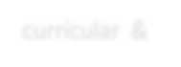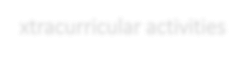
Co- curricular & Extracurricular activities

- EXPERIMENTAL LEARNING: 06
01. QUIZ & ASSIGNMENTS
Objectives:
01 It increases thinking ability , Knowledge,
response speed & Listening Skills.

- FIELD & IIDUSTRY
TRIPS 05

02. STUDENT SEMINARS:
Objectives:
02
Increases public speaking skills Decreases inferiority complex
Builds up self-confidence in students. Deep understanding of the topic.
Improve communication skills.

- ICT Classes
04

03 PG Entrance Coaching:
Objectives:
To orient the students to pursue Higher education.

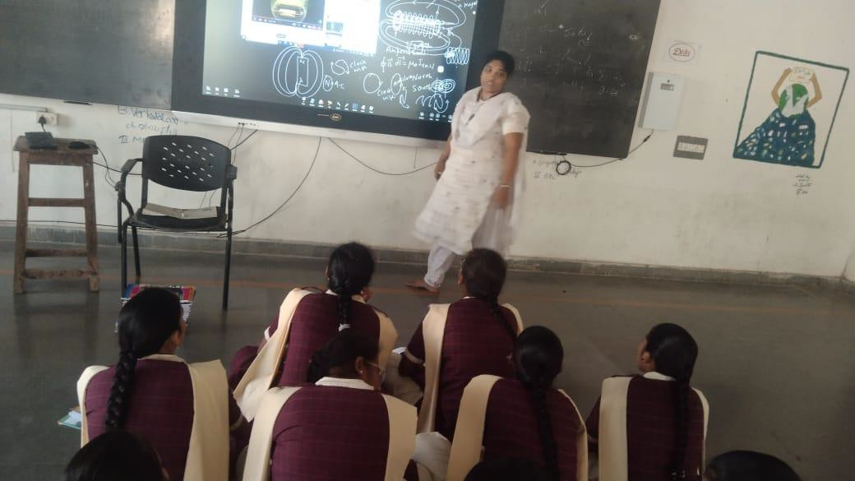
ICT TOOL FOR EFFECTIVE TEACHING IN CLASSROOM

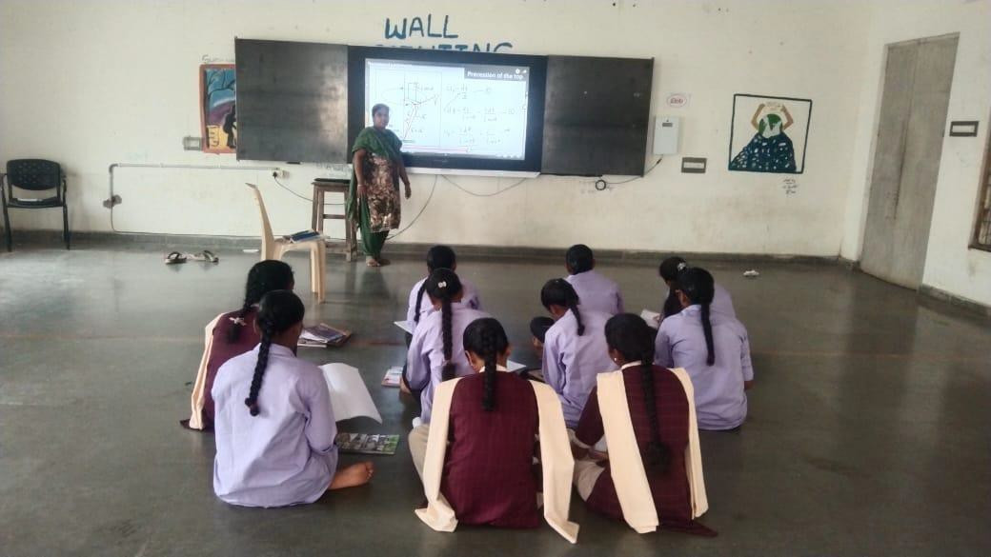

STUDENT ENROLLMENT& PROFILE

YEAR | MPC | MPCS
2018-19 | 25 | 25
2019-20 | 25 | 36
2020-21 | 28 | 30
2021-22 | 22 | 22
2022-23 | 29 | 12
2023-24 | 8 | 5
2024-25 | 0 | 15

RESULTANALYSIS–YEARWISE

2018-21

 | APPEARED | PASSED | PERCENTAGE
SEM1 | 50 | 50 | 100
SEM2 | 50 | 50 | 100
SEM3 | 49 | 49 | 100
SEM4 | 48 | 48 | 100
SEM5 | 48 | 48 | 100
SEM6 | 49 | 49 | 100

2019-22

 | APPEARED | PASSED | PERCENTAGE
SEM1 | 58 | 58 | 100
SEM2 | 58 | 58 | 100
SEM3 | 58 | 58 | 100
SEM4 | 58 | 53 | 91.3
SEM5 | 58 | 58 | 100
SEM6 | 58 | 52 | 89.6

2020-23

 | APPEARED | PASSED | PERCENTAGE
SEM1 | 53 | 48 | 90.5
SEM2 | 57 | 53 | 92.9
SEM3 | 48 | 46 | 95.8
SEM4 | 48 | 48 | 100
SEM5 | 49 | 49 | 100
SEM6 | 49 | 49 | 100

2021-24

 | APPEARED | PASSED | PERCENTAGE
SEM1 | 51 | 51 | 100
SEM2 | 50 | 49 | 98
SEM3 | 51 | 50 | 98
SEM4 | 50 | 48 | 96
SEM5 | 51 | 50 | 98
SEM6 | 49 | 49 | 100

PIONEERSOFTHEDEPARTMENT

- Name of the Lecturer: M.NAGASRI M.Sc.
- Year of joining :2018
- Name of the Lecturer: K.MANASA .M.Sc. Year of joining in department:2019
- Name of the Lecturer: B.HAREESH
- joining in department:2019

The staff members presently working in the department
  - Name of the lecturer: A.SWARNAKUMARI .M.Sc., B.Ed, NET
  - YearofjoininginDepartment:2024
  - Name of the lecturer: M.MANGA VENI M.Sc.,
  - YearofjoininginDepartment:2024
Number of Teaching Posts Sanctioned
  - One regular post and one guest post

NAME OF  THE LECTURER | Qualification | Designation | Specialization | Exp.in years
Smt.  A.SWARNAKUMARI | M.Sc.  B.Ed,NET | Regular | ---SOLID STATE PHYSICS---- | 16
M.MANGAVENI | M.Sc., | Guest | -------- | 3
The department have been regularly conducting the following activities.
- Fieldtrips
- Student classroom seminars
- Quiz programs
- Group discussion
- Student assignments
- Extension Lectures

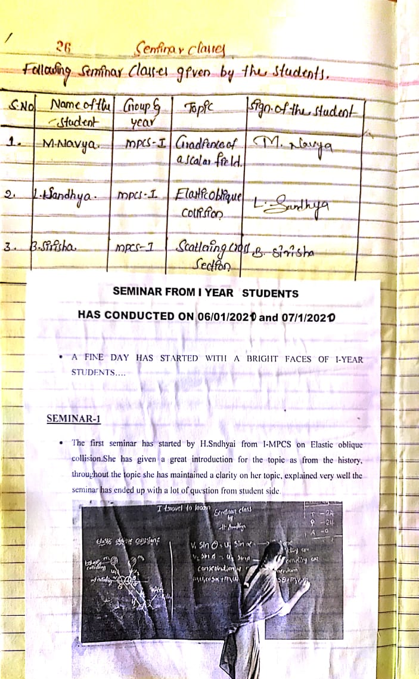
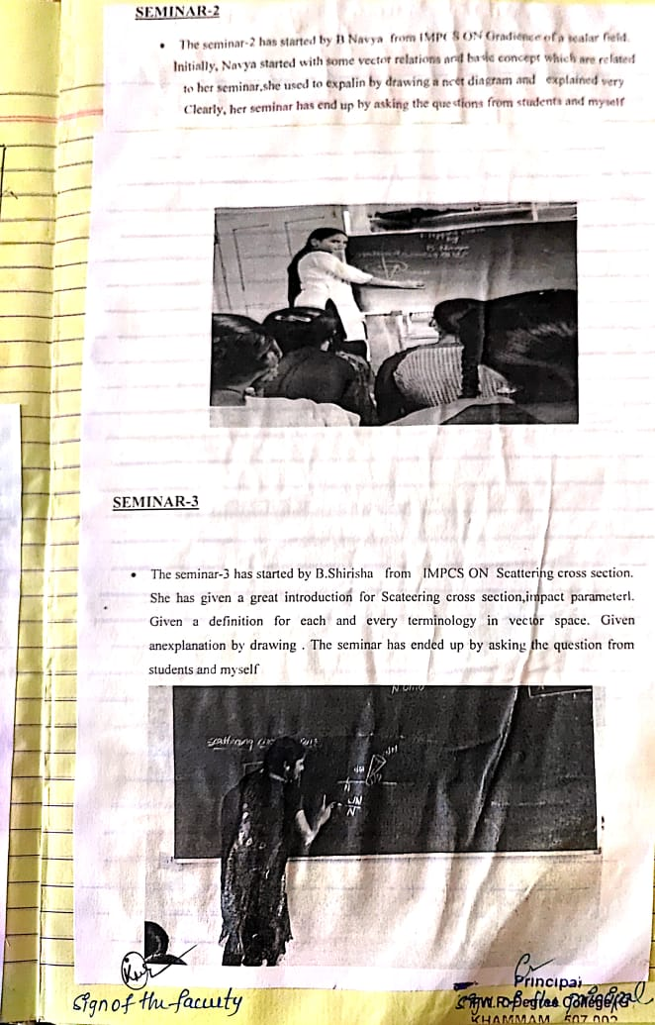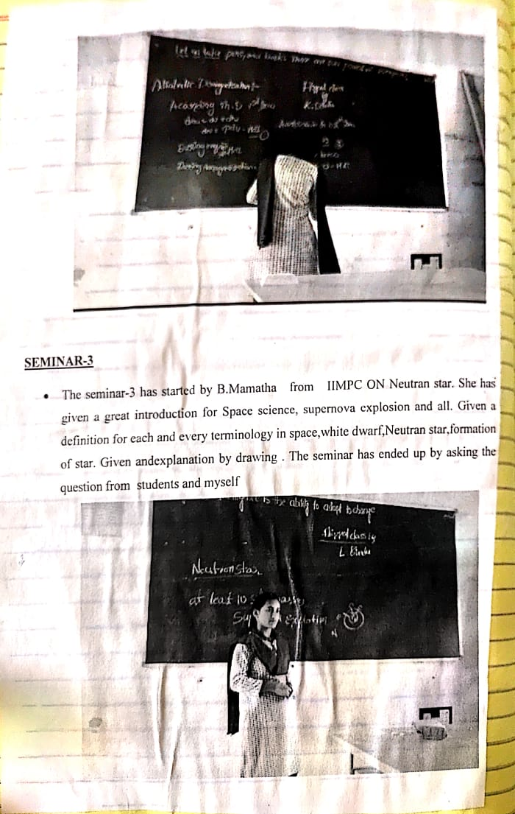
DEBATE TOPIC: NUCLEAR ENERGY IS GOOD OT NOT??

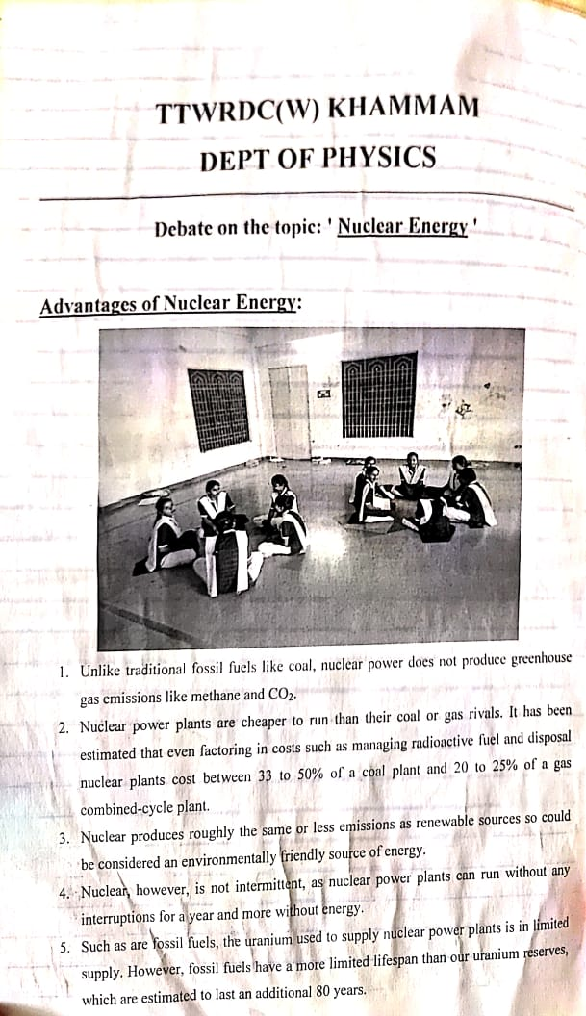
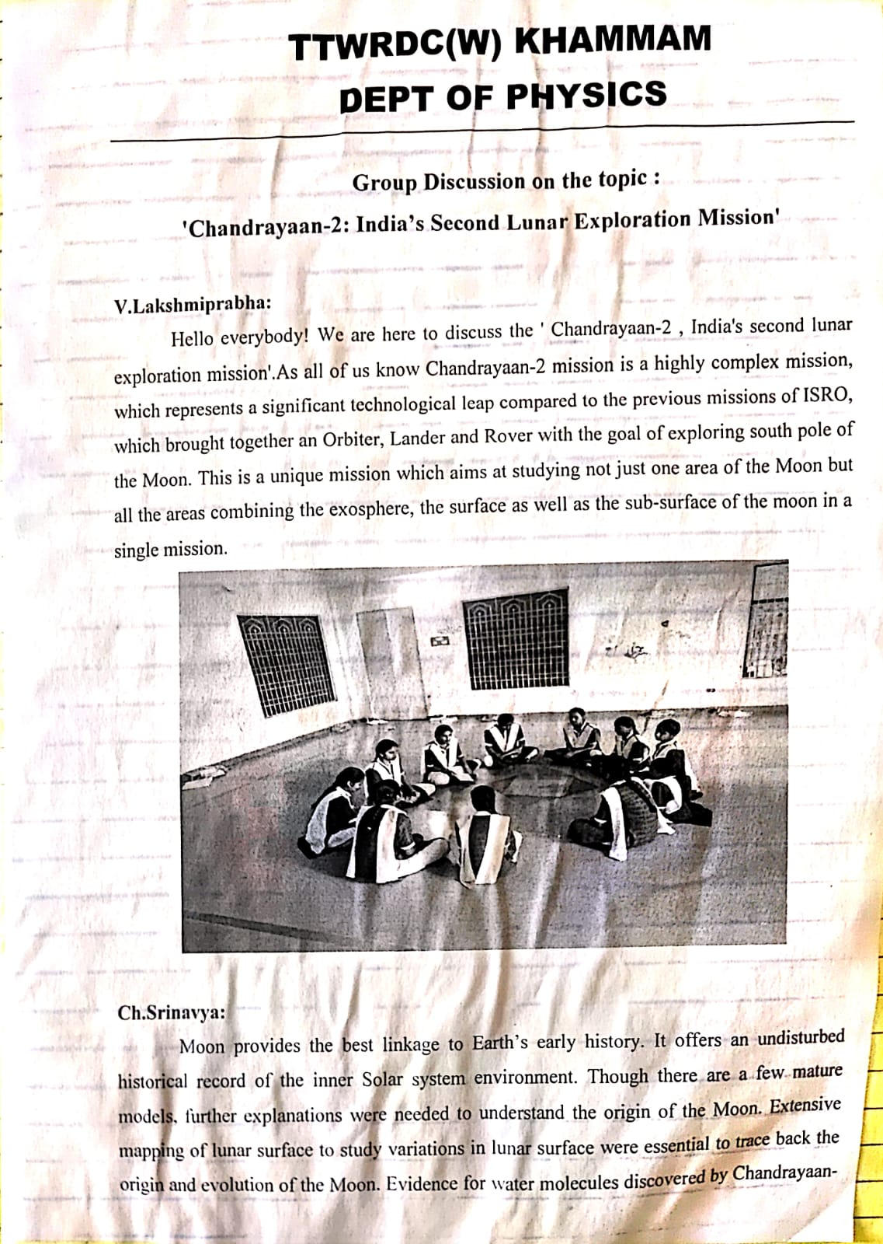
GROUP DISCUSSION
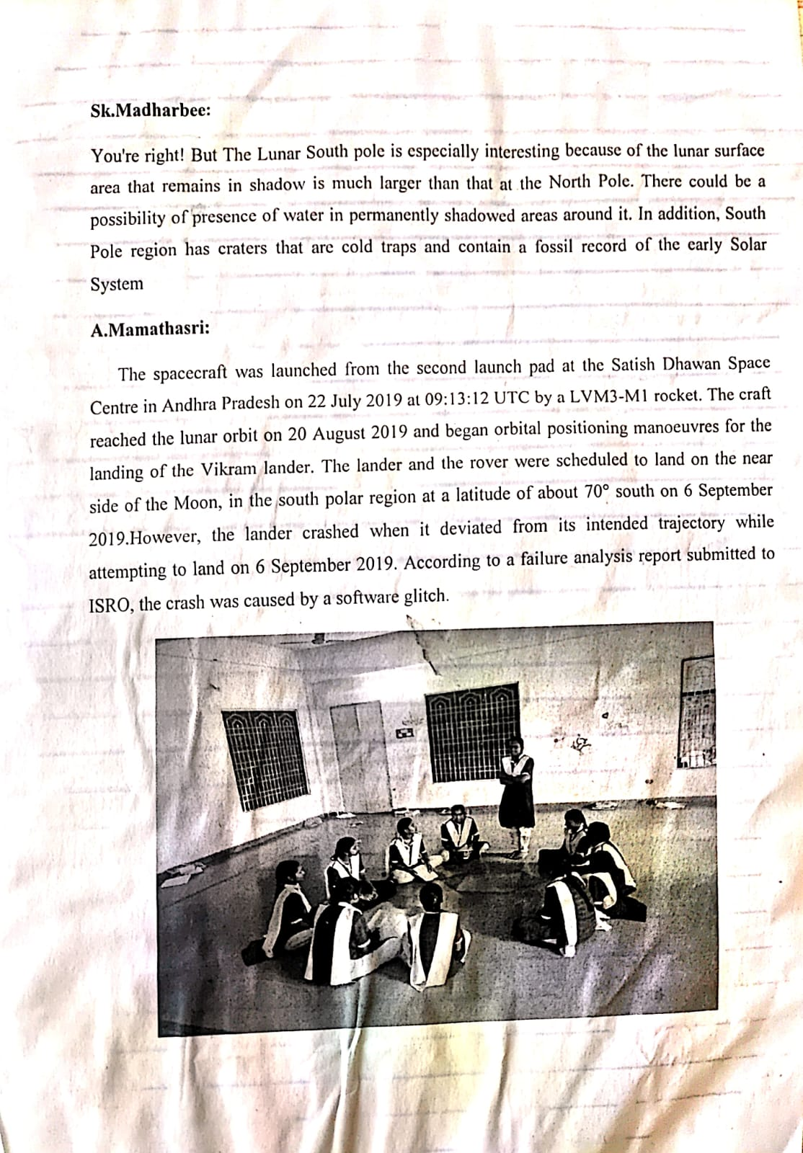
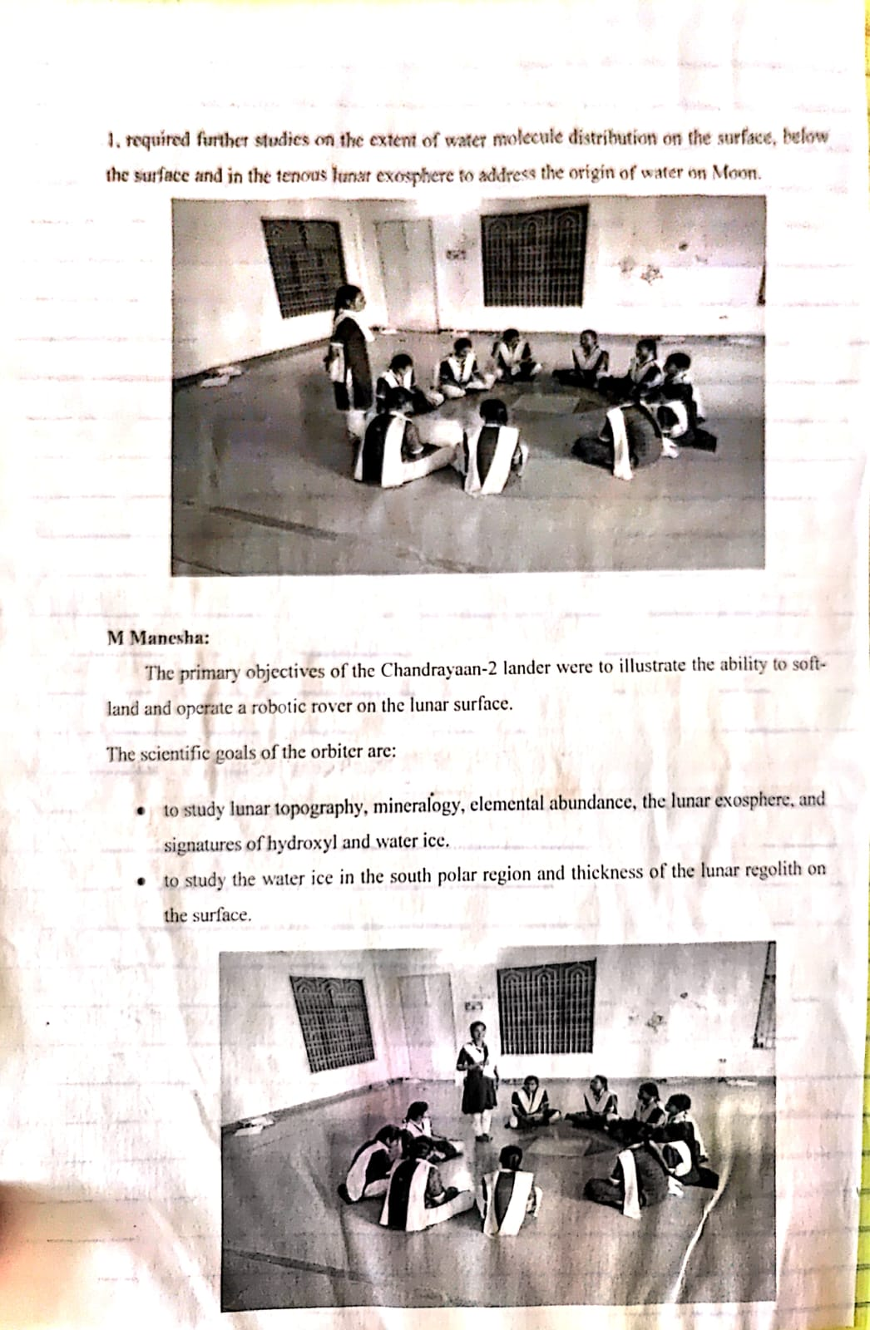
ICT TOOLS USED WHILE LEARNING

CRITERIAIII
RESEARCH AND INNOVATION AND EXTENSION ACTIVITIES.

EXTENSION LECTURES

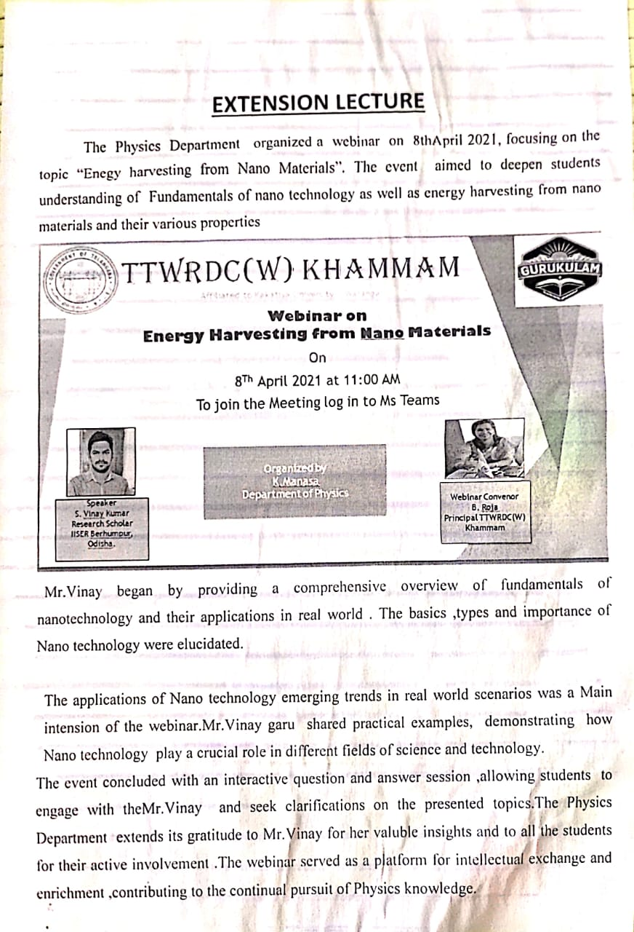
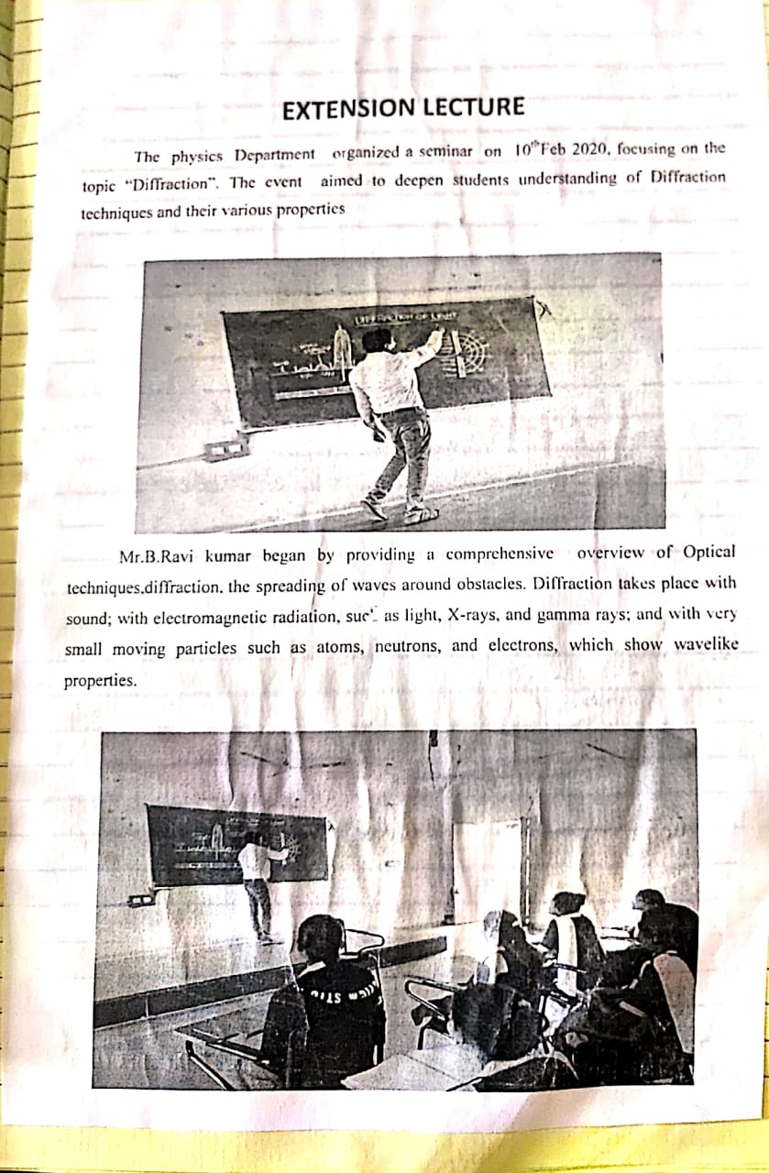

CRITERIA –IV INFRASTRUCTUREANDLEARNINGRESOURCES

LABORATORY&EQUIPMENT

B.Sc.(Physicspracticals)–Iyear Semester - I

Paper–I::MechanicsPracticals
- Measurement oferrors –simple Pendulum.
- Calculation of slope and intercept of a Y= mX +C graph by theoreticalmethod (simplependulum experiment)
- Studyofacompoundpendulum-determination o f„g‟and„k‟.
- Y‟byuniformBending
- Y byNon-uniformBending.
- MomentofInertiaof aflywheel.
- RigiditymodulibytorsionPendulum.
- Determinesurfacetension ofaliquidthroughcapillaryrise method.
- DeterminationofSurface Tension ofaliquid by anyother method.
- DetermineofViscosityof a fluid.

B.Sc.(PhysicsPracticals)–Iyear Semester - II

Paper–II::WavesandOscillationsPracticals
- Studyof dampingof an oscillatingdisc in Air andWaterlogarithmic decrement.
- Studyof Oscillations under Bifilar suspension-Verification ofaxis theorems
- Studyof oscillations of amass under different combinationofsprings-Series andparallel.
- Verificationof Lawsofa stretchedstring(Three Laws).
- Determinationoffrequencyofabar-Melde‟sexperiment.
- ObservationofLissajousfiguresfromCRO-Frequencyratio.Amlitudeandphasedifferenceof two waves.
- Volume Resonator–determination offrequencyof atuning fork.
- Velocityof Transverse wavealongastretched string.
- Studyofdampingofabarpendulum-dampingfactor
- Studyof coupledoscillator-resonance

B.Sc.(PhysicsPracticals)–IIyear Semester - III

Paper–III::ThermalPhysics Practicals
- Co-efficientofthermalconductivityofabadconductorbyLee‟smethod.
- MeasurementofStefan‟sconstant.
- SpecificheatofaliquidbyapplyingNewton‟slawofcoolingcorrection.
- Heatingefficiencyof electricalkettlewith varyingvoltages.
- Calibrationofthermocouple
- CoolingCurveofametallic body
- Resistancethermometer
- Thermalexpansionofsolids
- Studyofconversionofmechanicalenergytoheat.
- DeterminetheSpecificofasolid( graphiterod)

B.Sc.(PhysicsPracticals)–IIyear Semester - IV

Paper–IV::Optics Practicals
- Thickness of awireusingwedge method.
- Determinationofwavelengthoflight usingBiprism.
- DeterminationofRadiusofcurvatureofagivenconvexlensbyformingNewton‟srings.
- Resolvingpower of grating.
- Studyofopticalrotation-polarimeter.
- Dispersivepower ofaprism
- Determinationofwavelengthoflightusingdiffractiongratingminimumdeviationmethod.
- Wavelengthoflightusingdiffraction grating–normalincidence method.
- Resolvingpower ofatelescope.
- Refractiveindexofaliquidandglass(BoysMethod).
- Pulfrichrefractometer–determinationofrefractiveindexofliquid.
- WavelengthofLaserlightusingdiffractiongrating.

B.Sc.(PhysicsPracticals)–IIIyear Semester - V

Paper– V::ElectromagnetismLab

PHYSICS LABORATORY
  - To verifythe Thevenin Theorem
  - ToverifyNorton Theorem
  - To verifySuperposition Theorem
  - Toverifymaximum power transfer theorem.
  - TodetermineasmallresistancebyCareyFoster‟s bridge.
  - Todeterminethe(a)currentsensitivity,(b)chargesensitivity,and(c)CDRofaB.G.
  - Todeterminehigh resistancebyleakagemethod.
  - TodeterminetheratiooftwocapacitancesbyDeSauty‟sbridge.
  - Todetermineself-inductanceofacoilbyAnderson‟sbridgeusingAC.
  - Todetermineself-inductanceofacoilbyRayleigh‟smethod.
  - TodeterminecoefficientofMutual inductancebyabsolute method.

B.Sc.(PhysicsPractical)–IIIyear Semester - V
Paper:VI(A)SolidState Physics

- Measurementofsusceptibilityof paramagnetic solution(Quinck`sTubeMethod)
- TomeasuretheMagneticsusceptibilityofSolids(Guoy‟smethod)
- TodeterminetheCouplingCoefficientof aPiezoelectric crystal.
- Tomeasurethe DielectricConstantofadielectricMaterialswith frequency
- Tostudythe polarization-electricfield(P-E)hysteresisloopof aFerroelectric Crystal.
- Todraw theB-Hcurveof FeusingSolenoid& determineenergyloss from Hysteresis.
- Tomeasuretheresistivityofasemiconductor(Ge)withtemperaturebyfour-probemethod(room temperature to 150ºC) and to determine its band gap.
- TodeterminetheHall coefficientofasemiconductor sample.
- Calculationofd-valuesofagivenLaue‟spattern.
- Calculationofd-valuesofpowerdiffraction method.
- Tostudythe spectralcharacteristicsofaPhoto-Voltaiccell.
- .VerificationofBragg‟sequation.

LISTOF EQUIPMENTS
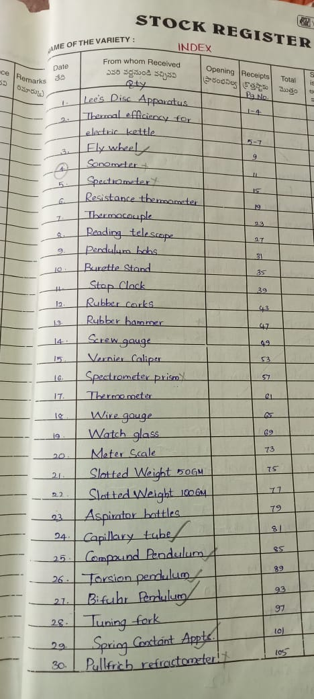

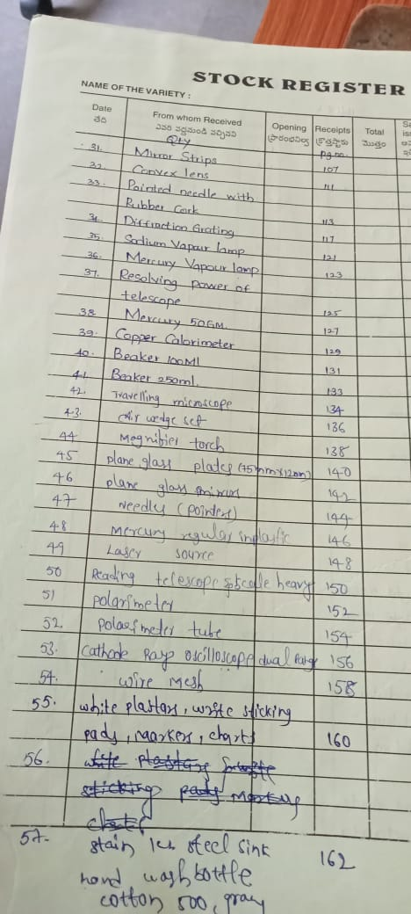
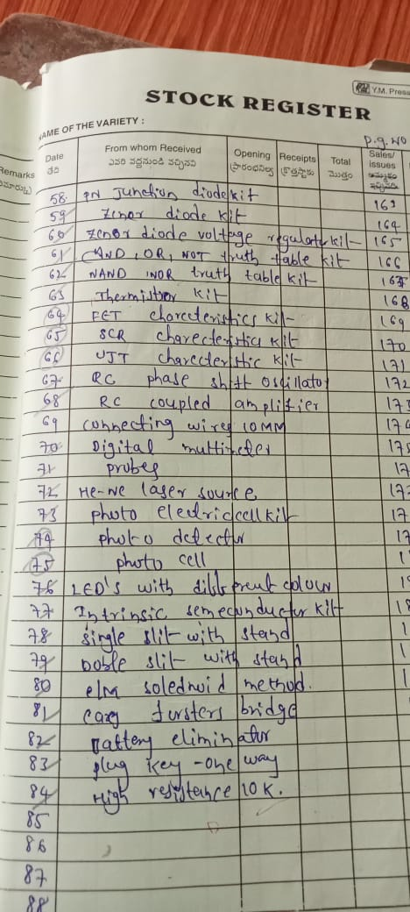
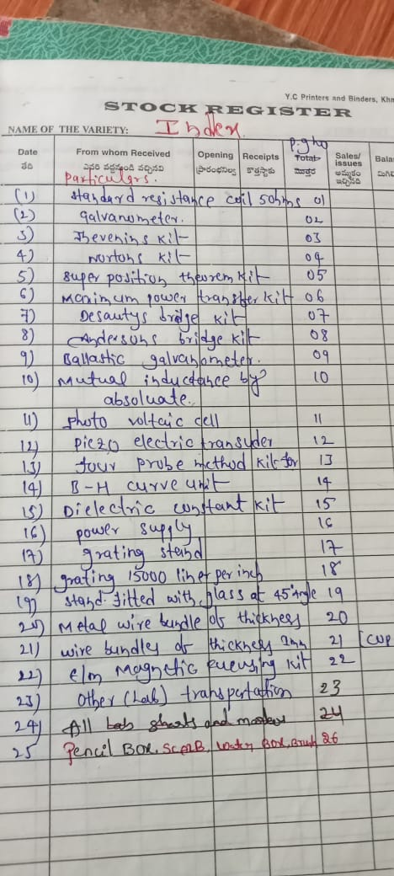

FURNITURE

DEPARTMENTALLIBRARY
DepartmentofZoologyhasaLibrarywith10referencebooks,04Nospractical Manuals and 02 Nos PG entrance books .

S.no | BOOKS | No
1 | ReferenceBooks | 10
2 | PracticalManuals | 04
3 | PGentranceBooks | 02

CRITERIA –V STUDENT SUPPORTIVE AND
PROGRESSION.

S.No | Name of  student | Graduate  from | PG/B.Ed | year | Institute  name
1  2 | V.LAXMIPRABHA  A.MAMATHA SRI | B.sc  B.sc | M.Sc.,  M.Sc., | 2020-21  2020-21 | OSMANIA UNIVERSITY  OSMANIA UNIVERSITY
3 | CH.SRINAVYA | B.sc | M.Sc., | 2020-21 | OSMANIA UNIVERSITY
4 | A.PRAVALIKA | B.sc | M.Sc., | 2021-22 | OSMANIA UNIVERSITY
5 | M.SANDHYA | B.sc | M.Sc., | 2021-22 | NIZAMCOLLEGE  OU,HYD
6 | D.ANITHA | B.sc | M.Sc.,  GEOPHYSICS | 2021-22 | OSMANIA UNIVERSITY
7 | S.SONIYA | B.sc | M.Sc.,  ELECTRONICS | 2021-22 | TELANGANA UNIVERSITY
8 | K.KRISHNAVENI | B.sc | M.Sc.,(electronics and communication) | 2023-24 | NIZAM COLLEGE

CRITERIA-VI
GOVERNANANCE LEADERSHIP AND MANAGEMENT

DEPARTMENTALMEETINGS

At the departmental level, Department faculty members meet at necessary days to discuss academic matters like Distribution of syllabus among the faculty review of coverage of syllabus and result analysis and course out comes
,important date to celebrate,etc,.

S.NO | ACADEMICYEAR | NAMEOFTHE DEPARTMENT  INCHARGE | DESIGNATION
1 | 2017-18 | M.NAGASRI | LECTURER
2 | 2018-19 | K.MANASA | LECTURER
3 | 2019-20 | K.MANASA | LECTURER
4 | 2020-21 | B.HAREESH | LECTURER
5 | 2021-22 | B.HAREESH | LECTURER
6  7  8 | 2022-23  2023-24  2024-25 | B.HAREESH  B.HAREESH  A.SWARNAKUMARI | LECTURER  LECTURER  LECTURER

CRITERIA- VII
INSTITUTIONAL VALUES AND BEST
PRACTICES

INSTITUTIONALVALUES AND BESTPRACTICES
.
BEST PRACTICES.
1. In addition to the regular courses, our department offers Certificate and value added Courses.
2. Academic and Administrative Audit is conducted by an external expert to audit Teaching-Learning Process, infrastructure and research of the department every year.
3. Students are encouraged to give presentation so that they will learn the subjects thoroughly in addition to improving their communication and presentation skills.
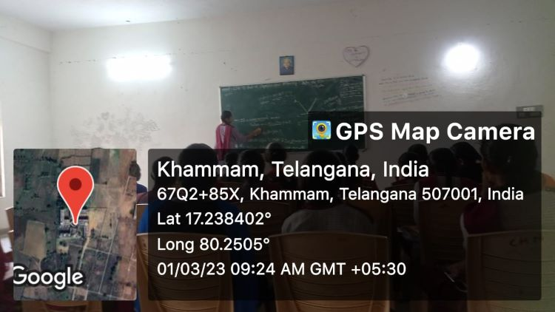
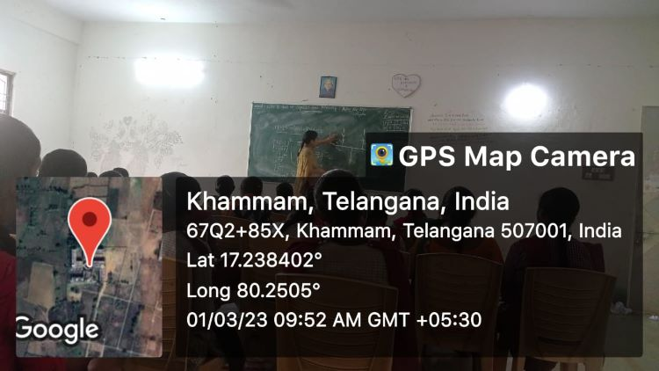
Group discussions and Debates:-
Department of Physics organized the group discussion for the BSc final year students keeping in the point of view to express their knowledge in a group. Department allotted the some topics in the syllabus of the BSc final year to the group of the students and told him to express their own view up to the one minute and then you had given the 5 minutes to discuss the topic in a group and finally one of them from you give the final conclusion regarding the Topics. 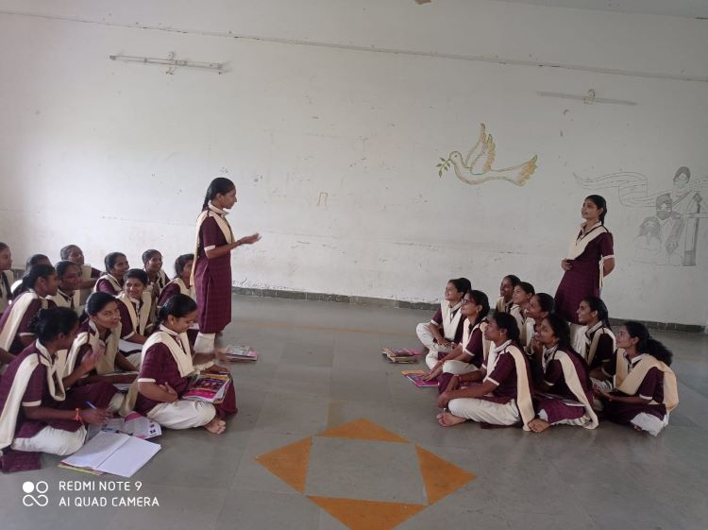
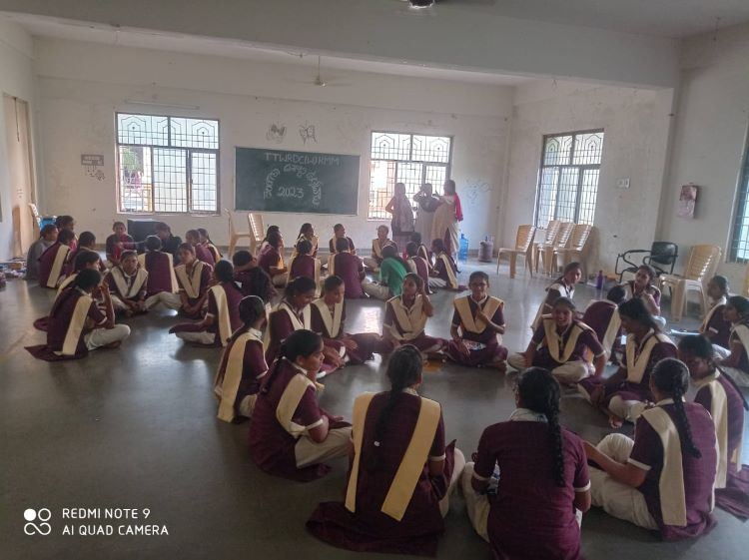

Coaching for CPGET and IIT - JAM.

OBJECTIVES OF THE PRACTICE:
Most of the students are interested to do their Post-Graduation in Physics but they are not in a proper planning due to lack of guidance. Keeping this in mind, our department is encouraging those students and offering coaching classes after their regular classes every year. As a result of our effort, many students got good ranks and joined university campuses and premiere institutions every year.
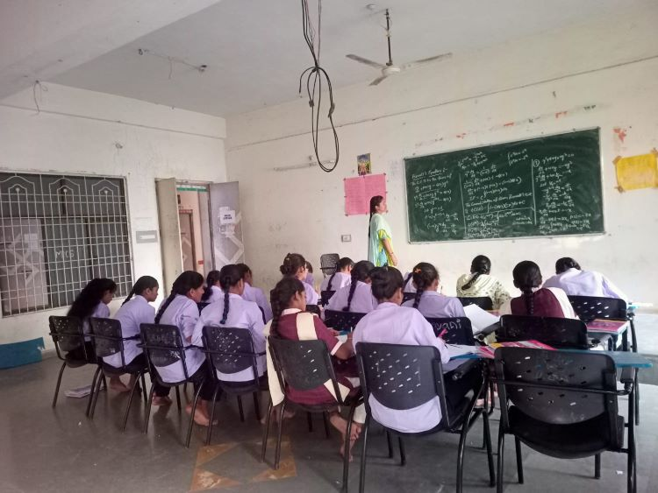
We told the students that they do not get good employment opportunities only by doing graduation and encouraged them to complete their masters. We motivated the students who are good at Mathematics to prepare for various PG entrance examinations and supported them with free entrance coaching.
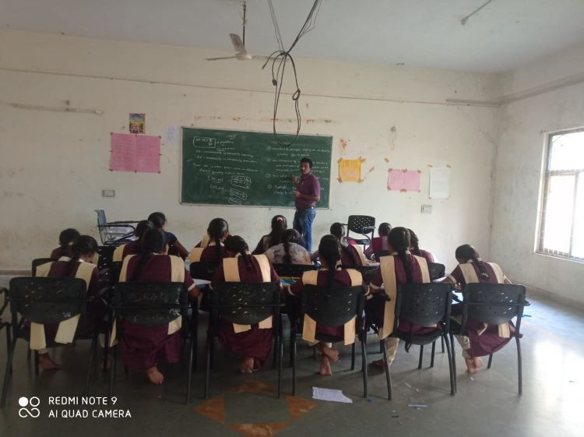
ACTION TAKEN:
We have identified the students who have good Analytical skills and motivated them to do M.Sc. Physics. We assured them to offer free coaching for various entrances and planned for the schedule. We have registered the students and conducted classes as per schedule. We also provided material and conducted model examinations. As a result of our effort, many students got good ranks and joined university campuses and premiere institutions.
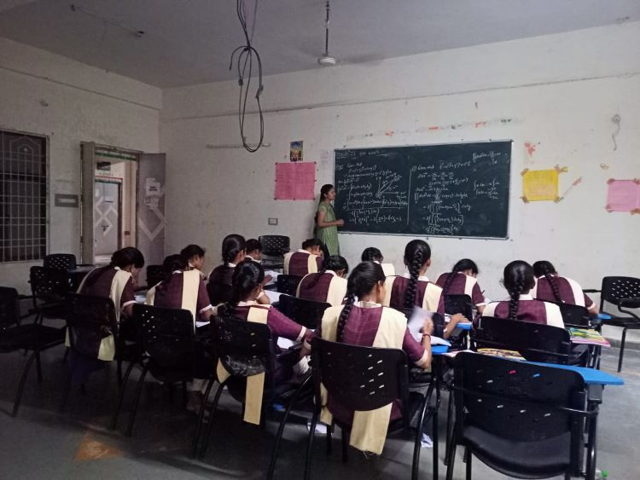
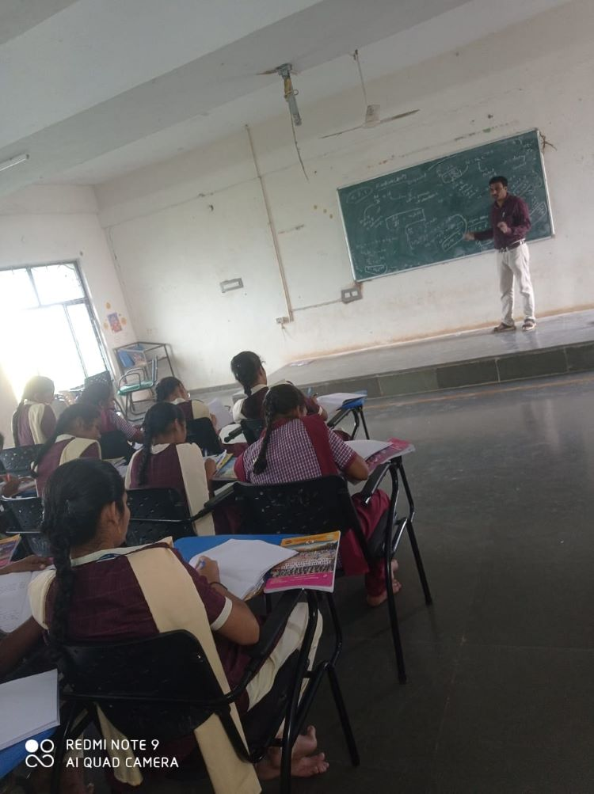
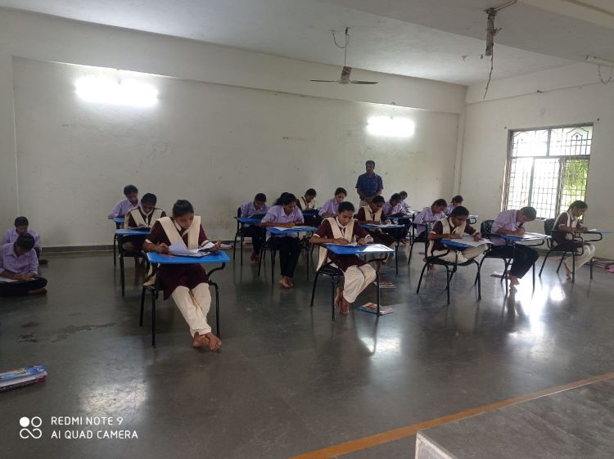

P.G STUDENT LISTS:
Department of Physics started free coaching started coaching from 2020-21,. Classes we conducted The following students are attended for PG Coaching and Got Admitted in Various Institutions.

Sl.No | Ht.No | NAME OF THE STUDENT | GROUP | Rank in CPGET | YEAR | Admitted Institution(M.Sc Physics)
1 | 69024290018 | V.Laxmi Prabha | lll MPCS | 22 | 2021 | OU Campus, Hyderabad.
2 | 69024290017 | Ch.Srinavya | III MPCS | 246 | 2021 | OU Campus, Hyderabad.
3 | 69024290069 | A.Mamatha Sri | III MPCS | 283 | 2021 | OU Campus, Hyderabad
4 | 69093770491 | T.Mankisha | III MPCS | 507 | 2021 | KU Campus,Warangal
5 | 69033350018 | M.Sandhya | III MPCs | 118 | 2022 | Nizam College Campus, Hyderabad.
6 | 69033350019 | DS.Anitha | III MPC | 243 | 2022 | OU Campus, Hyderabad
7 | 69033350006 | A.Pravalika | III MPCS | 329 | 2022 | KU Campus,Warangal
8 | 69033350115 | M.Ramya | III MPCS | 500 | 2022 | MG University, Nalgonda.
9 | 69033350015 | S.Soniya | III MPC | 715 | 2022 | TG University Campus, Nizamabad
10 | 69033350044 | K.Padmavathi | III MPC | 912 | 2022 | Admitted in B.Ed
11 | 69033350032 | M.Dhanalaxmi | III MPC | 1072 | 2022 | Admitted in B.Ed
12 | 69033350022 | V.Ramadevi | III MPCS | 1235 | 2022 | PG Centre,Siddipet.
13 | 69033350191 | D.Srilekha | III MPC | 1607 | 2022 | Admitted in B.Ed
14 | 69080280513 | K.Krishnaveni | III MPC | 383 | 2023 | KOTI Womens’ College Campus, Hyderabad.
15 | 69024050023 | K.Sravani | III MPCS | 1094 | 2023 | UPGC, Palamur University, Mahabubnagar.
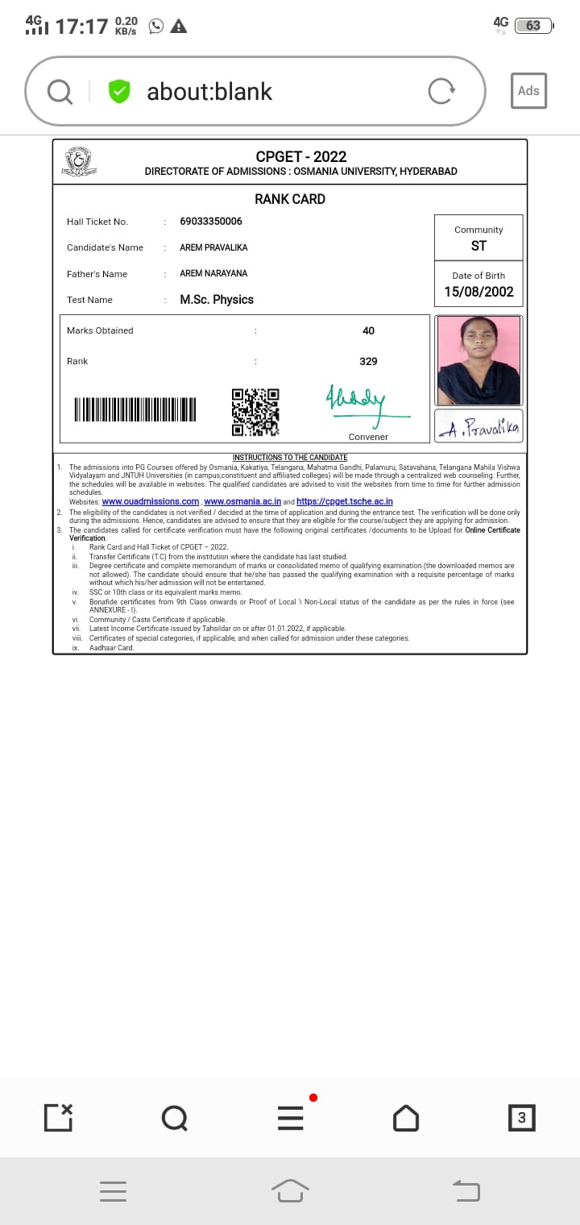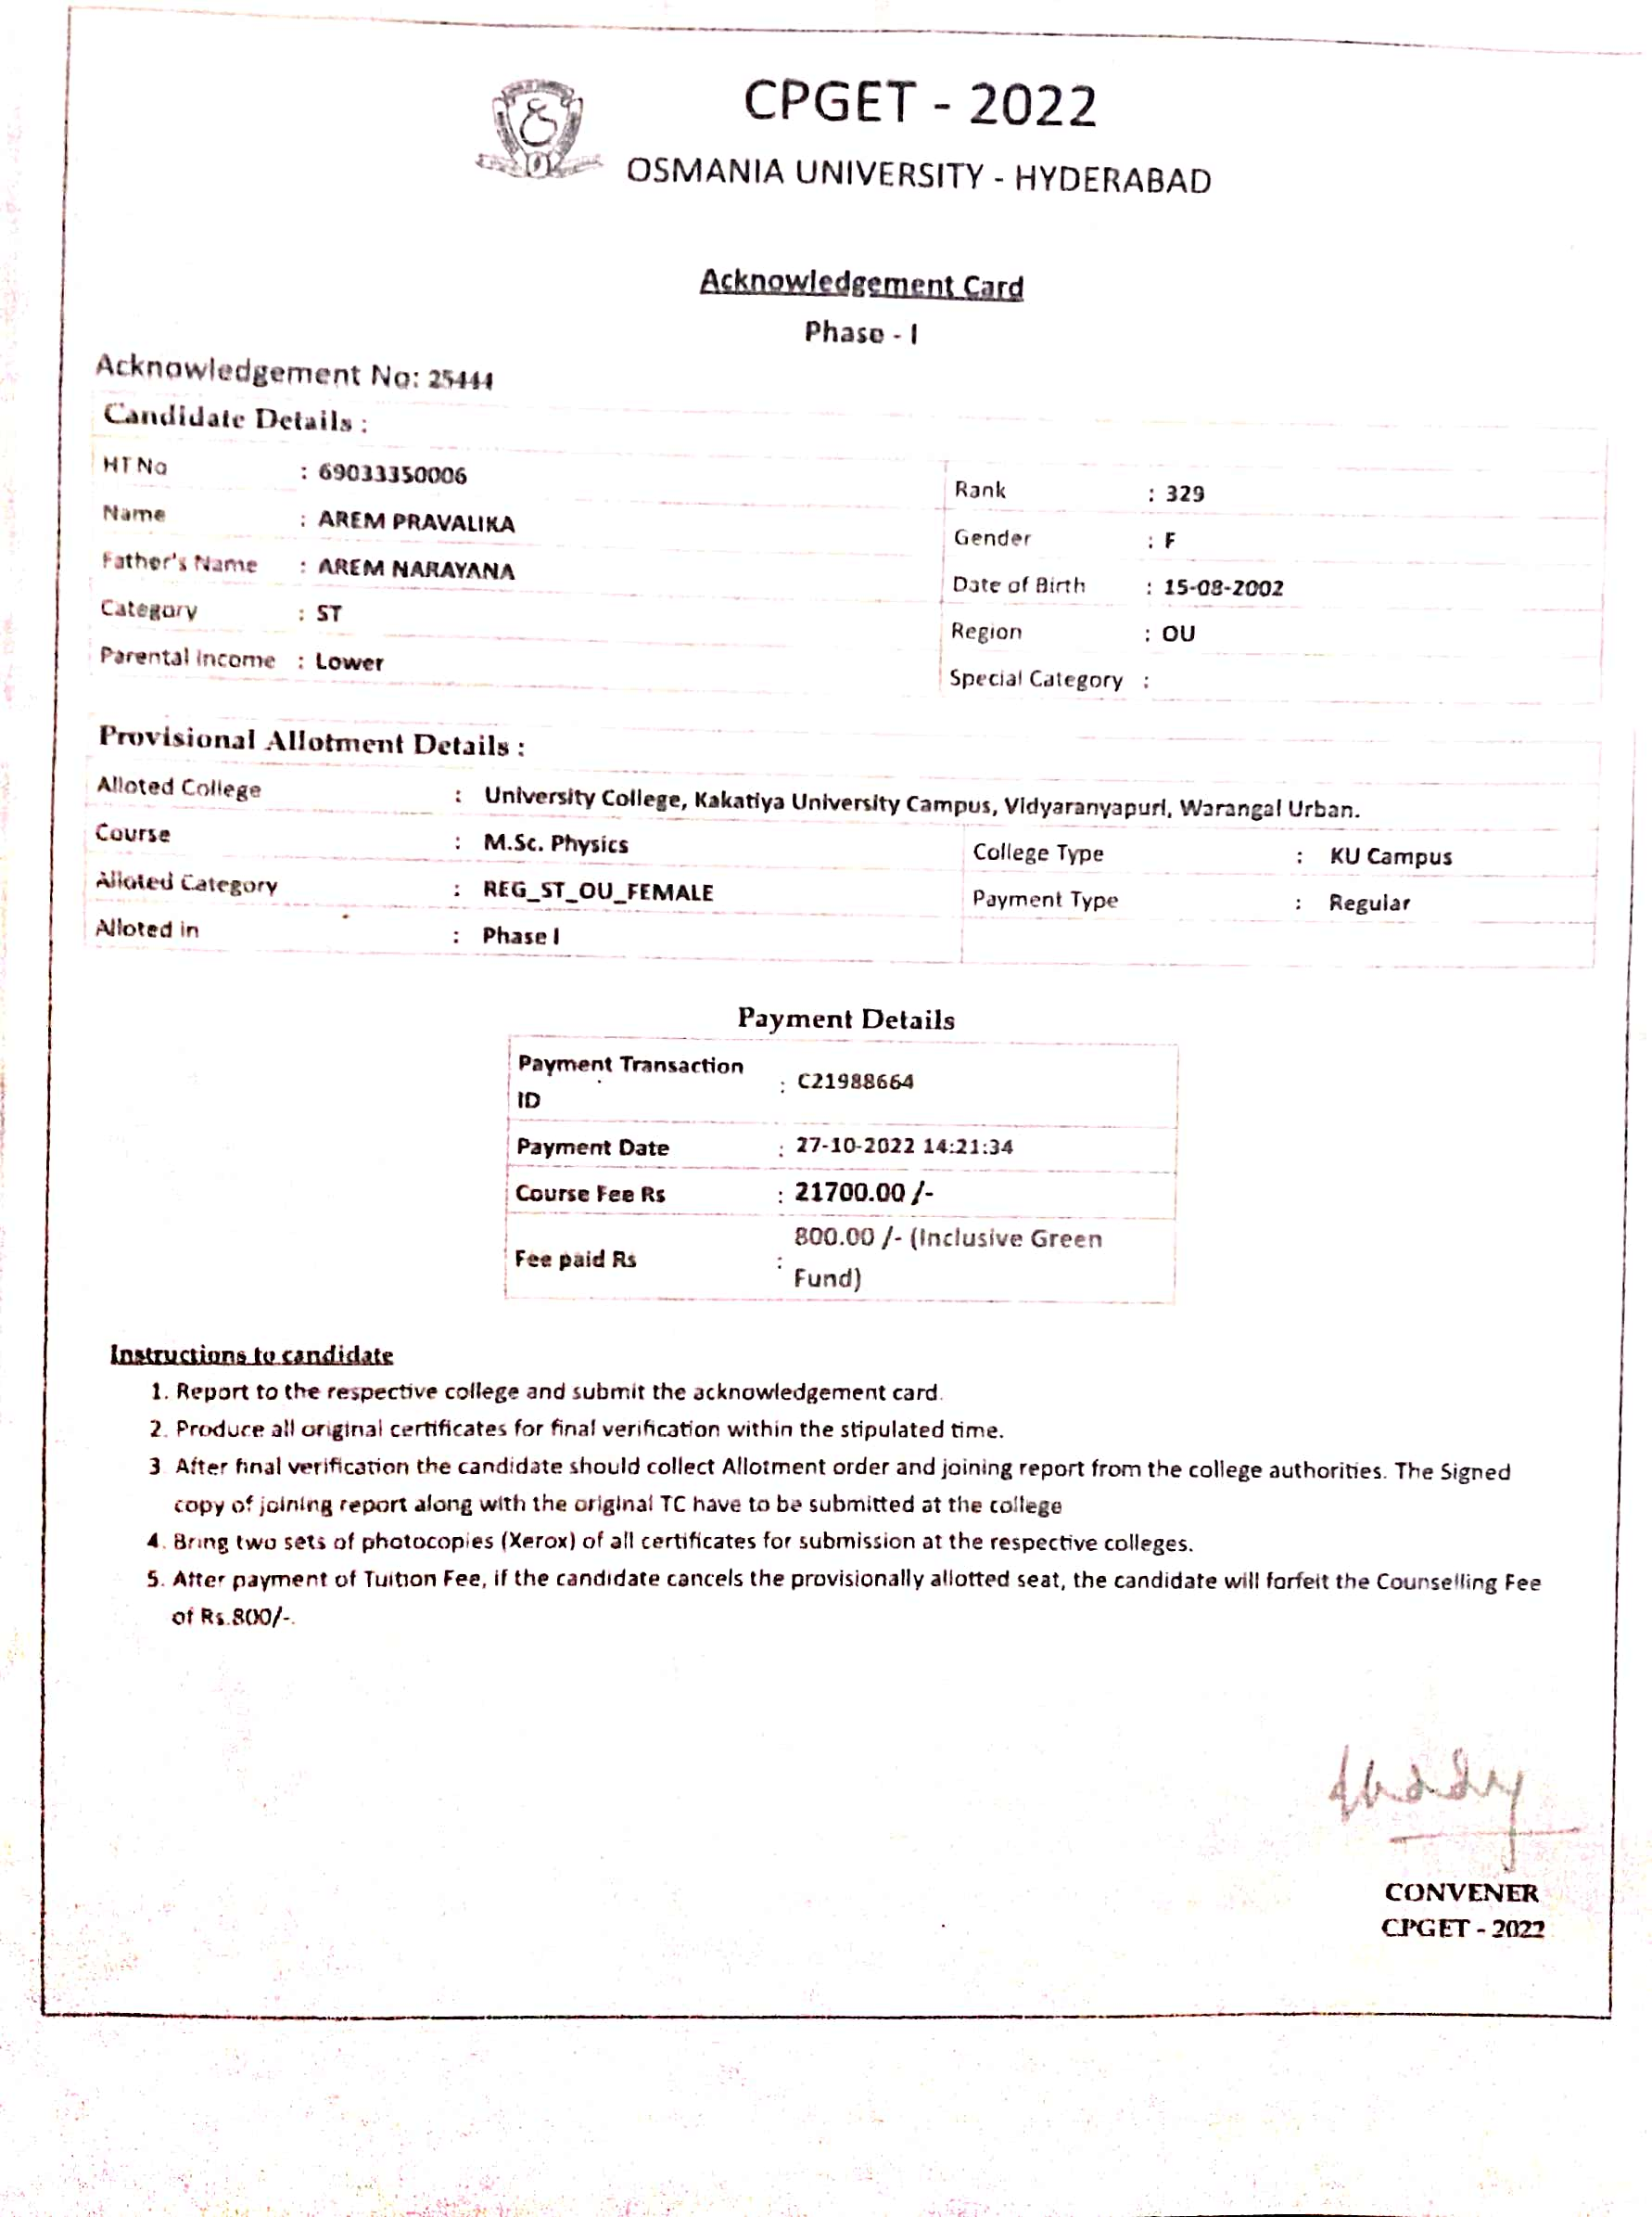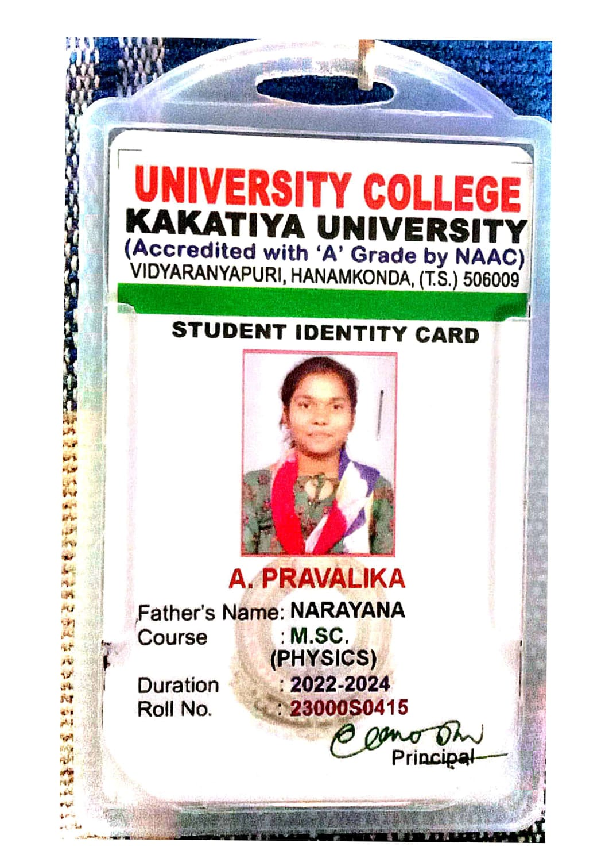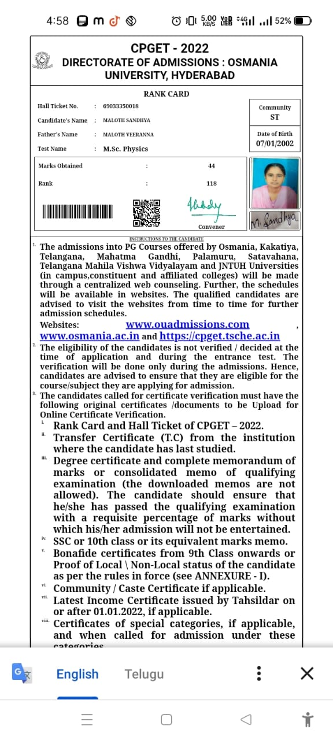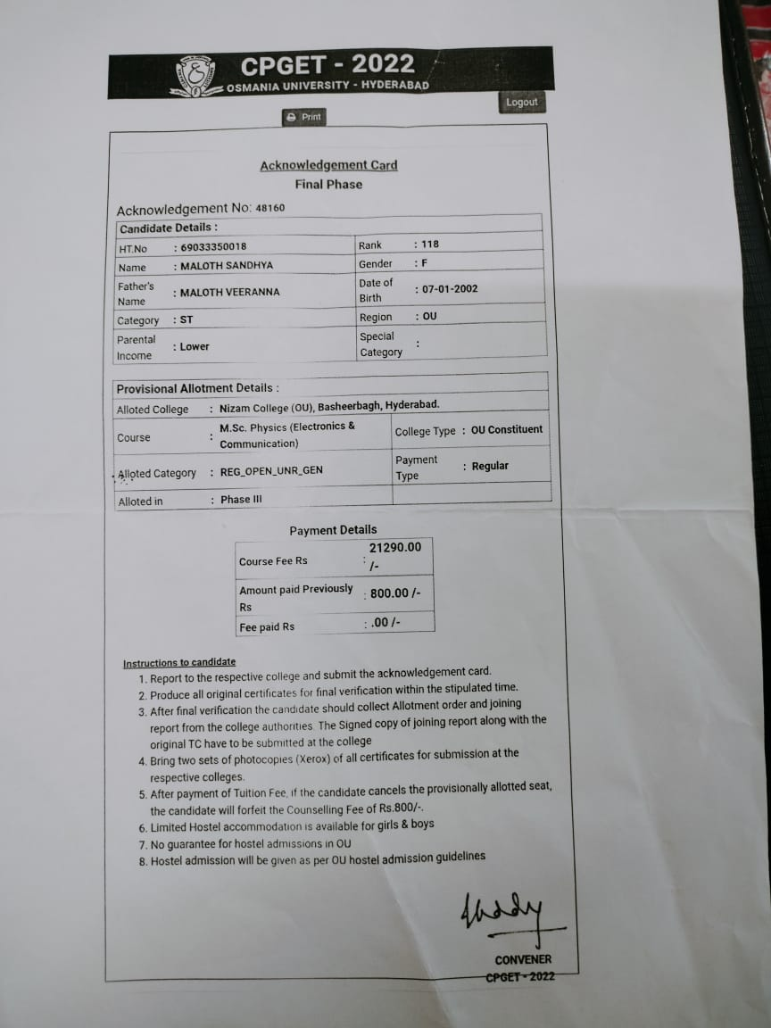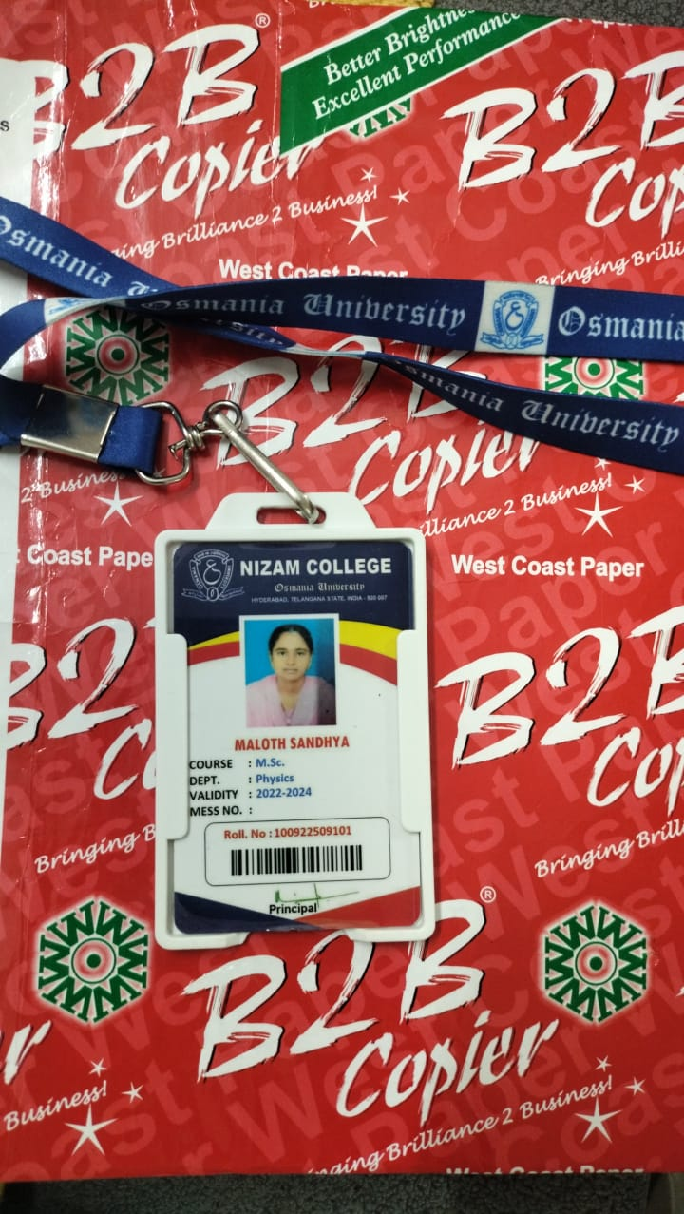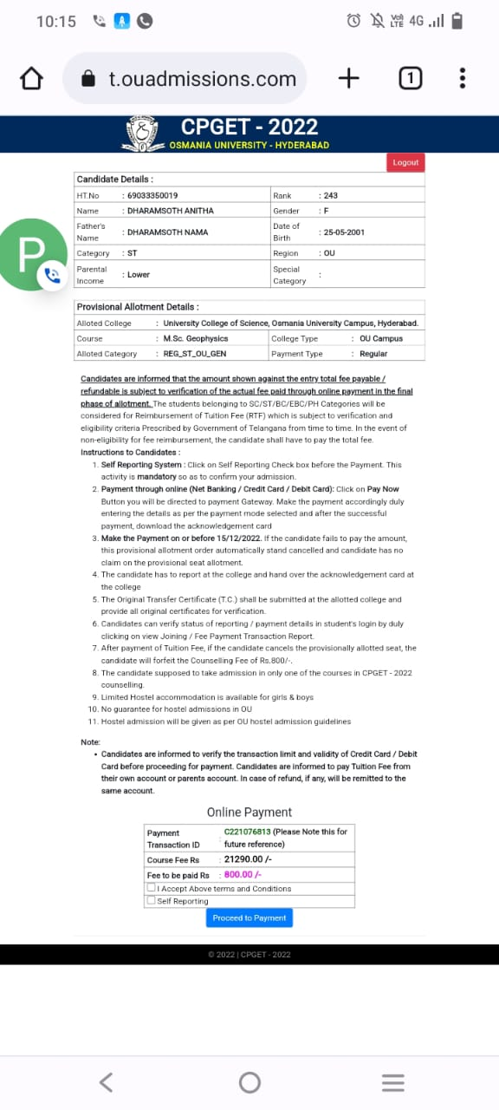
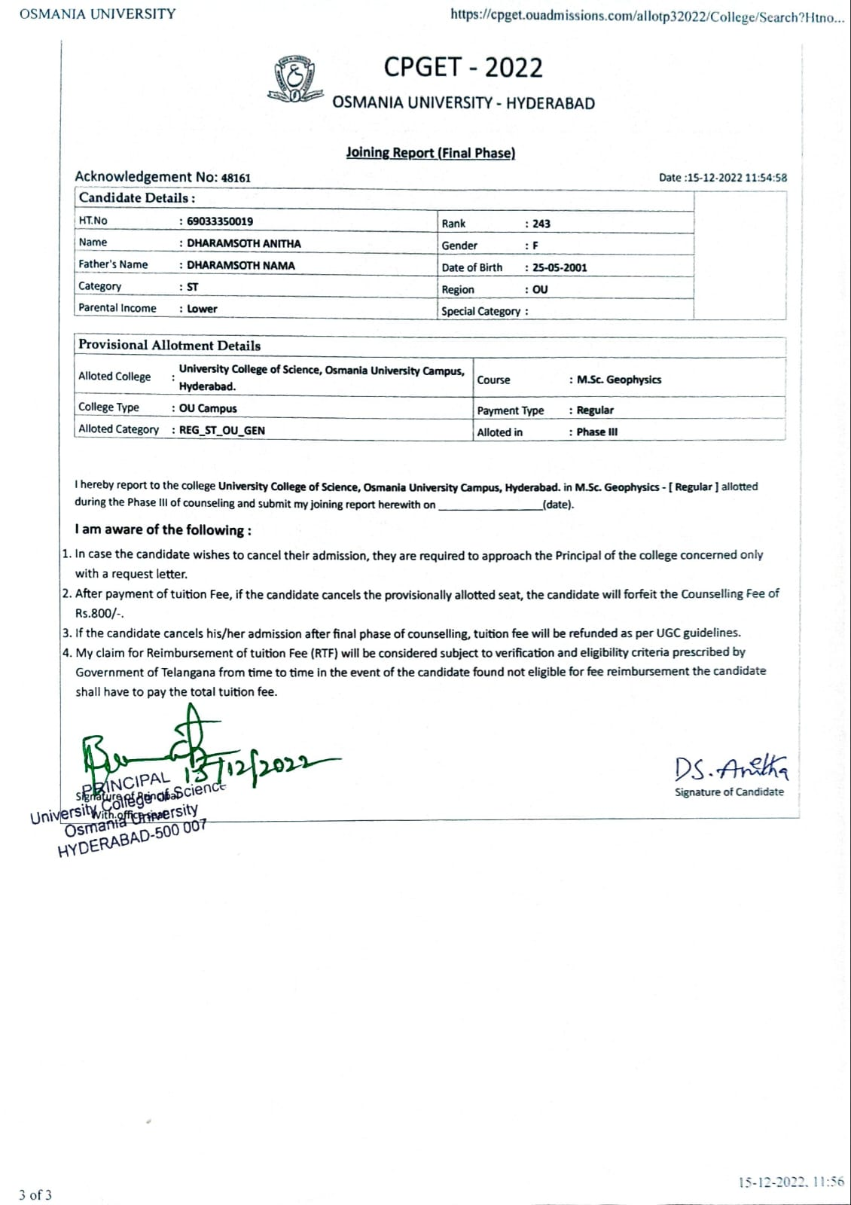
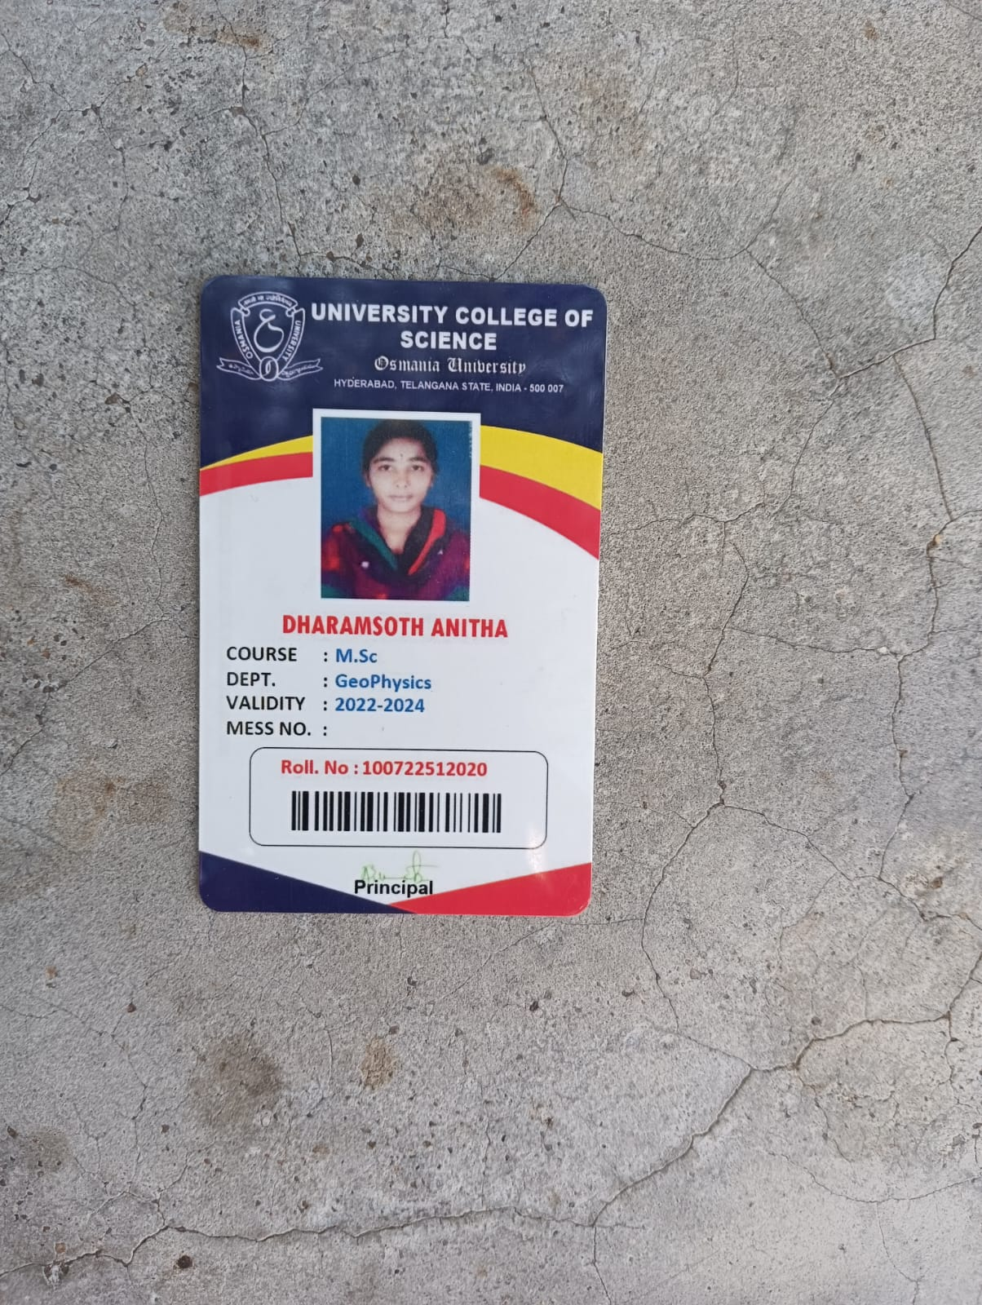
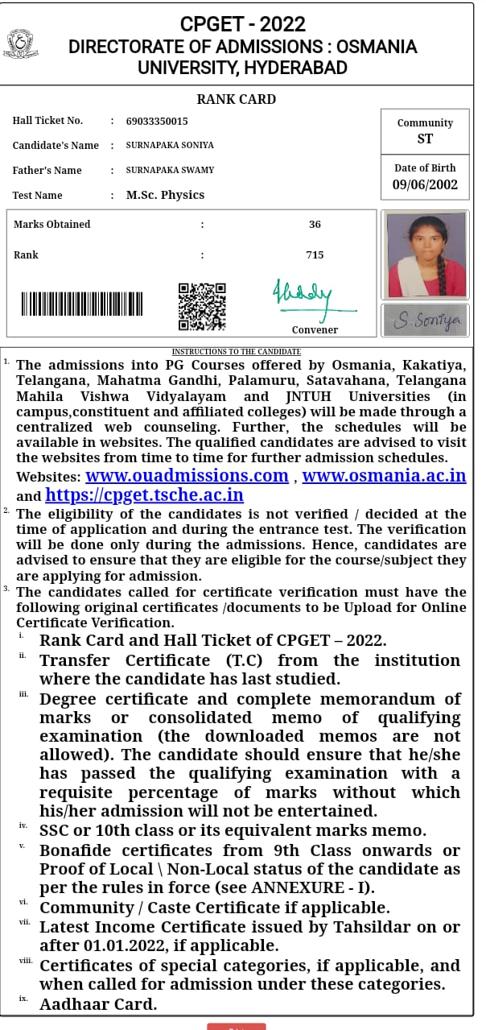
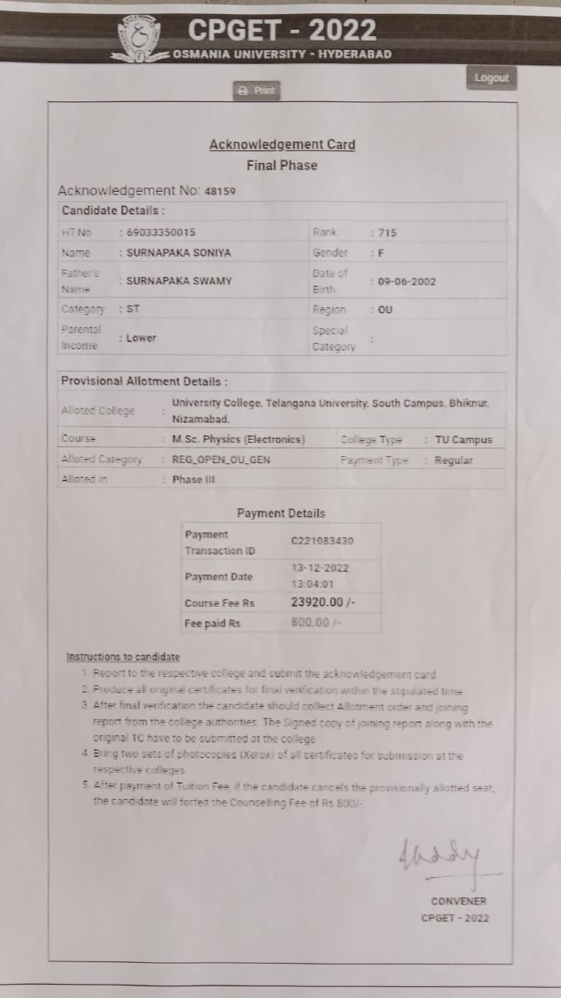
/8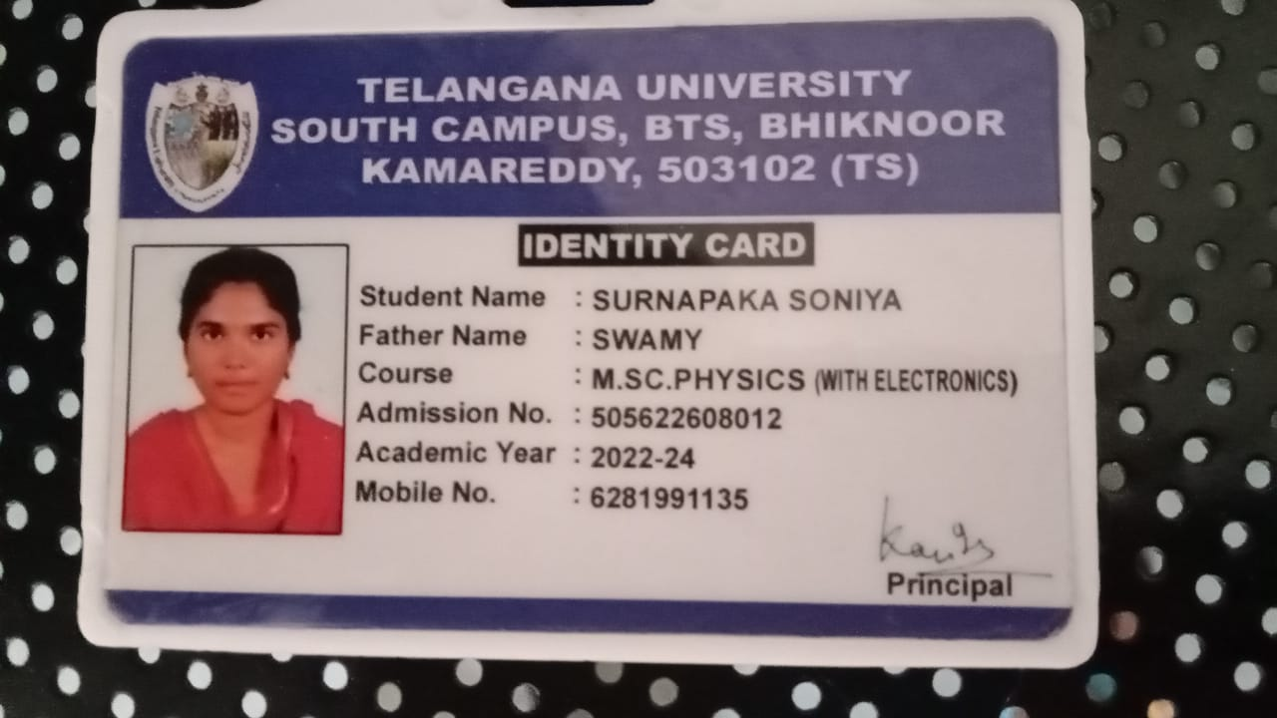

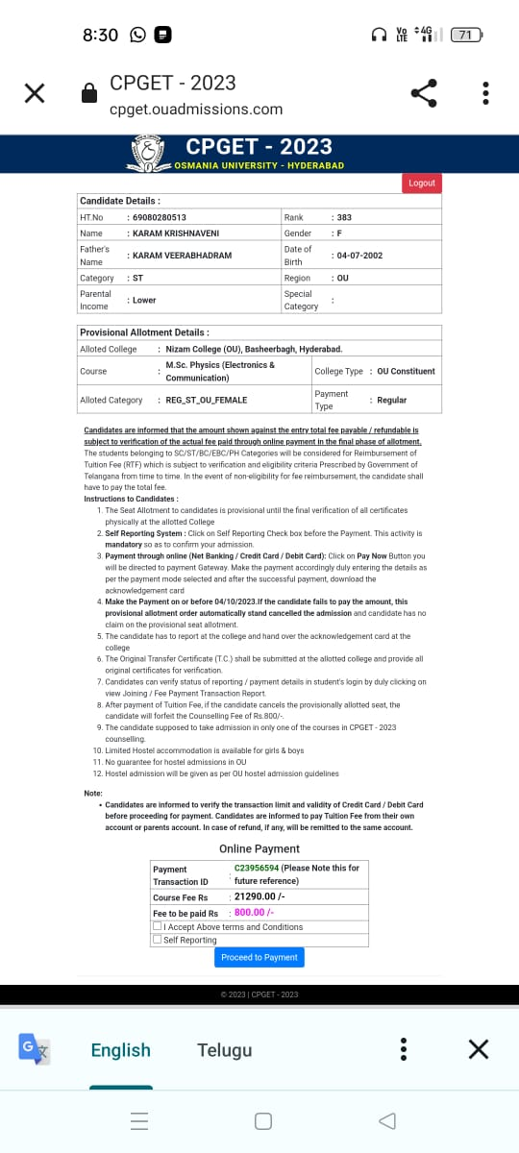

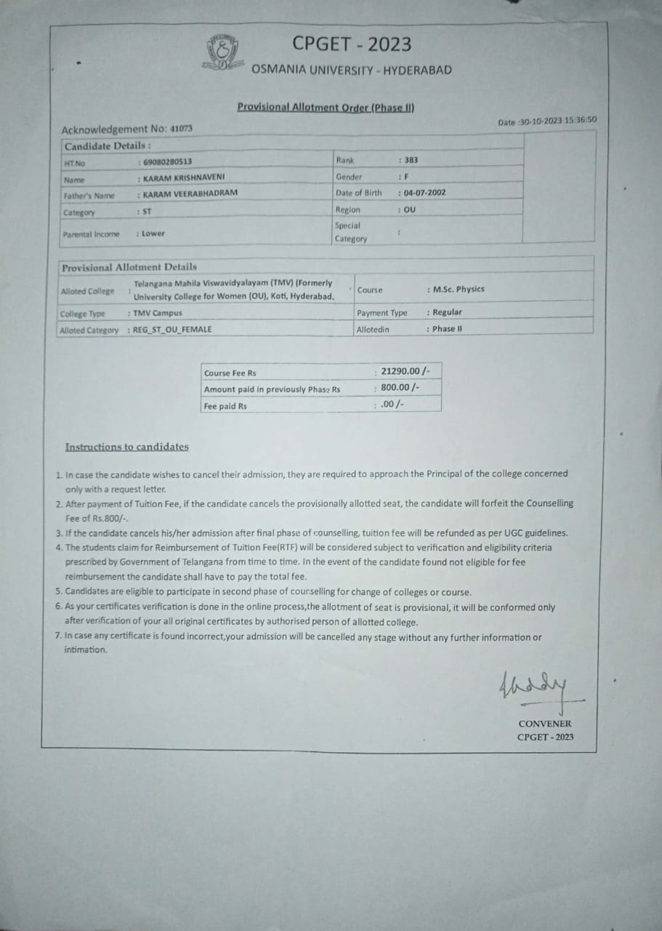
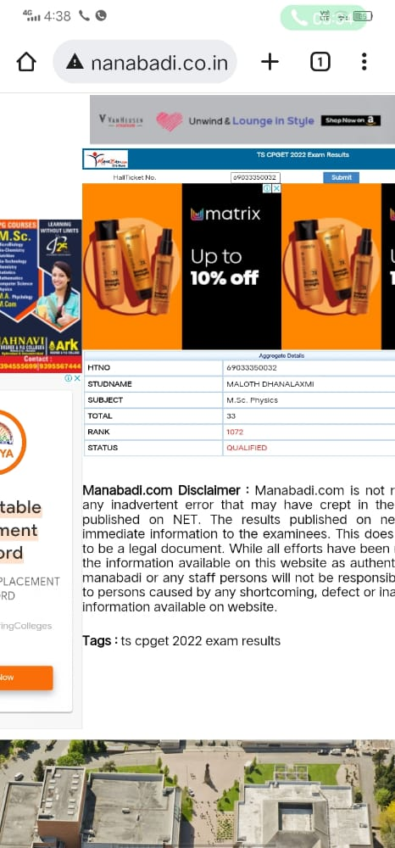
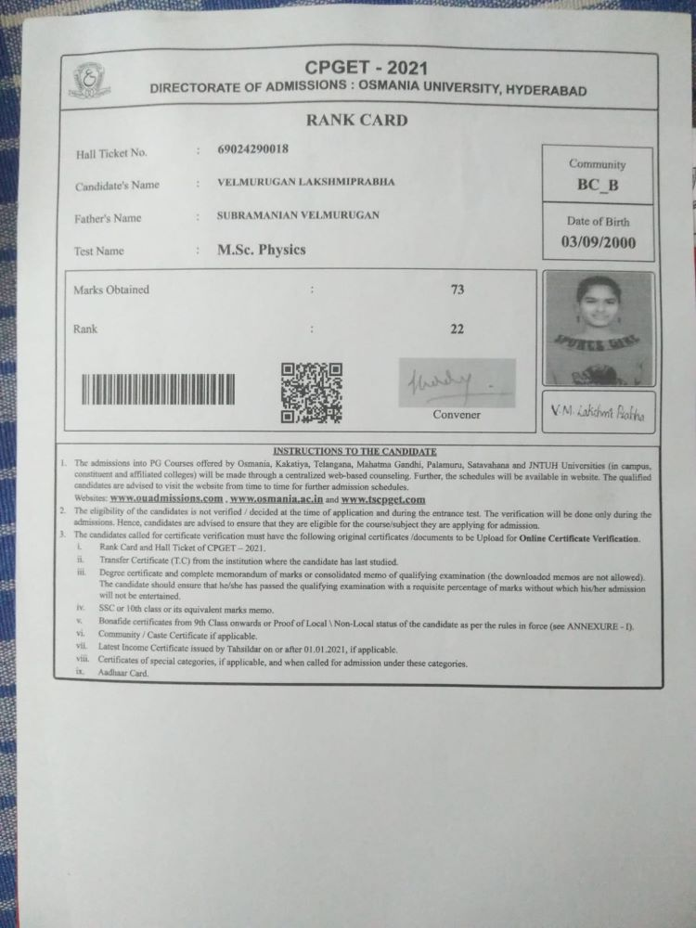
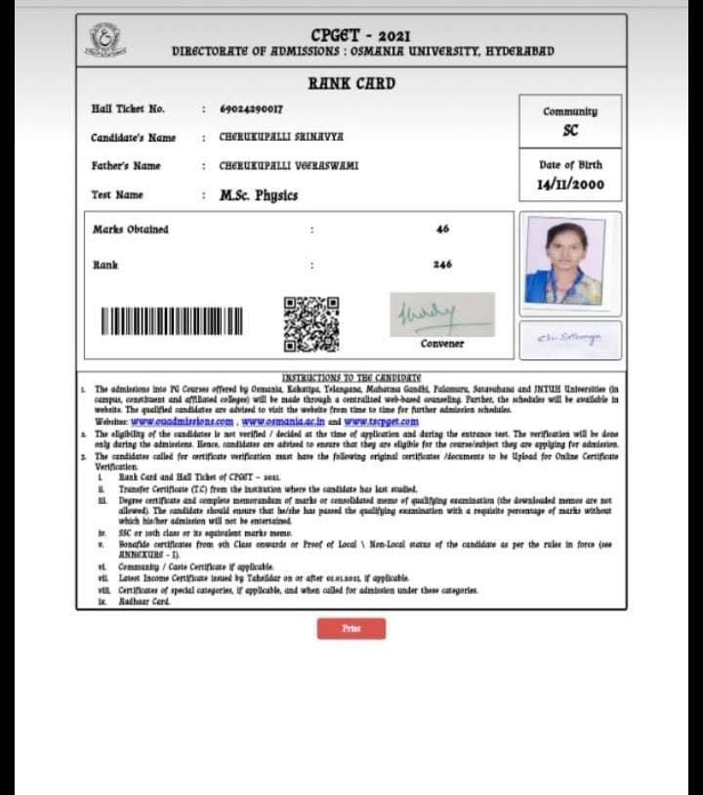
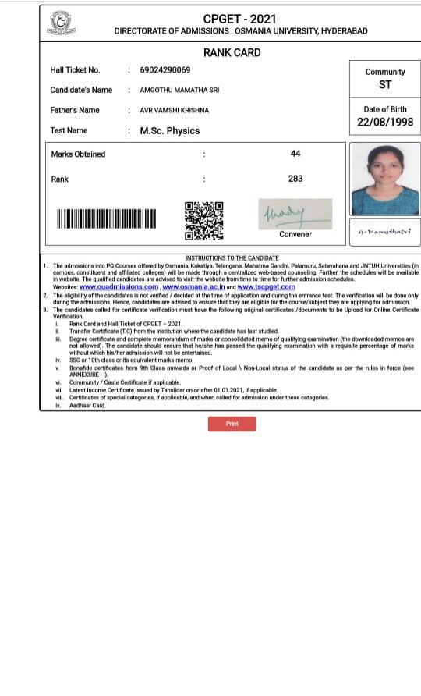

FuturePlans.
  - Tostrengthenthedepartmentitisproposedtoapplyfor sanction of well equipped laboratory, well established Departmental Library and supervisory ship.
  - Todevelopinterdisciplinaryaddoncourses.
  - Tointensifyextracurricularactivityinthedepartment.
  - ParticipationinInstitutionalSocialResponsibilityand Extension activities.
  - Forquickandaccurateinternalevaluationofthestudent performance.



